DESIGN AND IMPLEMENTATION OF A PROMT-AWARE LARGE LANGUAGE MODEL REQUEST ROUTING SYSTEM

BY

TERSEER SOLOMON TERZUNGWE-TEMBE (20231900)
SODIQ OMOTAYO ABDULWARIS (20231024)
MARYAM BAWA DAHIRU (242140247)
WAHIDA ABDULRASHEED BELLO (20231224)
KABIRU MABUDI AHMED (20230160)
ADRIEL MADUKWE OGBUREKE (20230922)

A PROJECT SUBMITTED TO
THE DEPARTMENT OF SOFTWARE ENGINEERING, FACULTY OF COMPUTING, NILE UNIVERSITY OF NIGERIA,
IN PARTIAL FULFILMENT OF THE REQUIREMENTS FOR THE AWARD OF THE DEGREE OF BACHELOR OF SCIENCE (B.Sc. HONS) IN SOFTWARE ENGINEERING,
NILE UNIVERSITY OF NIGERIA

NOVEMBER 2026

NILE UNIVERSITY OF NIGERIA

STATUS CONFIRMATION FOR BACHELOR’S PROJECT
PROJECT TITLE: DESIGN AND EVALUATION OF A HYBRID PROMPT-AWARE, MULTI-OBJECTIVE LARGE LANGUAGE MODEL ROUTING SYSTEM WITH AUTOMATIC FALLBACK
ACADEMIC SESSION: 2026/2027
We, TERSEER SOLOMON TERZUNGWE-TEMBE, SODIQ ABDULWARIS, [FULL NAME: MARYAM], [FULL NAME: WAHIDA], [FULL NAME: KABIRU], [FULL NAME: ADRIEL], agree to allow this degree project to be kept at the Library under the following terms:
- This Degree Project is the property of Nile University of Nigeria.
- The library has the right to make copies for educational purposes only.
- The library is allowed to make copies of this report for educational exchange between higher educational institutions.
- ** Please Mark (√)
 | CONFIDENTIAL | (Contains information of high security or of great importance to Nigeria as stipulated under the OFFICIAL SECRETS ACT )
 | RESTRICTED | (Contains restricted information as determined by the Organization/institution where research was conducted)
 | FREE ACCESS

_________________________ |  | Approved by,  __________________________
(STUDENTS' SIGNATURES) |  | (SUPERVISOR’S SIGNATURE)
Permanent Address :  [Permanent address of the group leader]  Date: ___________________ |  | Supervisor’s name:  [Supervisor's full name]  Date: ____________

CERTIFICATION
This is to certify that the project titled "Design and Evaluation of a Hybrid Prompt-Aware, Multi-Objective Large Language Model Routing System with Automatic Fallback" by TERSEER SOLOMON TERZUNGWE-TEMBE (20231900), SODIQ OMOTAYO ABDULWARIS (20231024)
, MARYAM BAWA DAHIRU (242140247), WAHIDA ABDULRASHEED BELLO (20231224)
, KABIRU MABUDI AHMED (20230160) and ADRIEL MADUKWE OGBUREKE (20230922) has been read and approved as meeting the requirements for the award of the degree of Bachelor of Science (B.Sc. Hons) in Software Engineering, Department of Software Engineering, Faculty of Computing, Nile University of Nigeria, Abuja.
……………………………….
[Supervisor's full name]
PROJECT SUPERVISOR

……………………………………
Assoc. Prof. Ibrahim Salihu Anka
HOD SOFTWARE ENGINEERING

…………………………………….
Prof. Joshua Abah
DEAN FACULTY OF COMPUTING

..........................................................
EXTERNAL EXAMINER

DECLARATION
We hereby declare that this project report is our own work and has not been submitted, in whole or in part, for any other degree or qualification. All sources consulted have been duly cited and acknowledged in the references, and any use of generative AI tools has been declared in this report.
Name (Student ID): TERSEER SOLOMON TERZUNGWE-TEMBE (20231900) Signature: ………………………
Name (Student ID): SODIQ OMOTAYO ABDULWARIS (20231024)
Signature: ………………………
Name (Student ID): MARYAM BAWA DAHIRU (242140247) Signature: ………………………
Name (Student ID): WAHIDA ABDULRASHEED BELLO (20231224) Signature: ………………………
Name (Student ID): KABIRU MABUDI AHMED (20230160) Signature: ………………………
Name (Student ID): ADRIEL MADUKWE OGBUREKE (20230922) Signature: ………………………

Supervisor : …………………………………………………….
[SUPERVISOR'S FULL NAME]

STATEMENT OF INDIVIDUAL CONTRIBUTIONS
Each member's planned role and main contributions are listed below. These follow the team's task distribution; each member will confirm or correct their own entry, in their own words, before signing.
S/N | Full name | Student ID | Role | Main contributions (modules, chapters, tasks) | Signature
1 | Terseer Solomon Terzungwe-Tembe | 20231900 | Group leader; routing algorithm and machine learning developer | Suitability predictor and selection policy (3.6.5, 3.7); sprint coordination; supervisor liaison
2 | Sodiq Abdulwaris | 20231024 | System architect; model integration, API and database developer | Architecture (3.6.1); provider adapters and reliability controller; database design (3.6.4)
3 | Maryam Bawa Dahiru | 242140247 | Backend developer; testing and evaluation developer | Gateway backend; replay and fault-injection harness; evaluation plan (3.9)
4 | Wahida Abdulrasheed Bello | 20231224 | System architect; documentation lead; testing and evaluation | Requirements (3.2, 3.5); Chapter Two coordination and references; test plan
5 | Kabiru Mabudi Ahmed | 20230160 | Frontend and backend developer; documentation | Administrator dashboard (3.6.6); requirements extraction; report assembly
6 | Adriel Madukwe Ogbureke | 20230922 | [Role to be agreed] | [To be agreed]

DECLARATION ON THE USE OF GENERATIVE AI TOOLS
Generative AI tools were used in preparing this proposal, as declared in the table below. The team remains responsible for all content and has checked, or will check before submission, every AI-assisted section against the original sources.
Tool and version | Task it was used for | Chapter / section | How the output was verified or edited
Claude (Anthropic), Claude Opus 5.5 in Claude Code, November 2026 | Drafted the proposal text from the team's research notes, design decisions and literature records; drew Figures 2.1 and 3.1 to 3.6 with Python scripts; formatted the document in the department template | Front matter; Chapters One to Three | [To be completed by the team: each section read and edited by its owner; every citation, number and figure checked against the original source]
AI-assisted literature summaries (earlier sessions; tool and version to be confirmed) | Reading notes for the 90 studies in the review register | Chapter Two | Summaries not treated as reading; key studies to be read in full and every reported figure checked

DEDICATION

We dedicate this project to God Almighty for His guidance, wisdom, strength, and grace throughout our academic journey. We also dedicate this work to our parents, families, and loved ones for their unwavering support, encouragement, and sacrifices throughout our studies. Finally, we dedicate this project to everyone who has contributed to our academic growth and inspired us to pursue knowledge, innovation, and excellence in the field of technology.

ACKNOWLEDGEMENT

We thank our supervisor, Dr. Emmanuel Aderemi, for guidance throughout this proposal, and the staff of the Department of Software Engineering, Nile University of Nigeria, for the Research Methodology modules that shaped its structure. We also thank our families for their support.

ABSTRACT

Applications that use large language models usually send every request to a single model. This wastes money on requests a cheaper model could answer, and choosing a weaker model instead loses quality on hard requests. Research routers predict which model should answer each request, but most choose between two models, optimise only average cost and quality, and are rarely compared with simple alternatives under the same conditions. Commercial gateways offer failover but publish no evaluation of their routing decisions. This project aims to design, implement and evaluate a hybrid prompt-aware routing system that selects, for each request, a model from a mixed pool of local and hosted models under quality, cost and latency constraints, with automatic fallback when a provider fails. The research follows a Design Science Research approach, implemented through 6 2-week Scrum sprints. The Python FastAPI router will have a single OpenAI-compatible endpoint. The router will predict the quality of each model for a specific prompt based on a simple task classifier and embedding-based look-up of the previously evaluated prompts (with scores), and select the lowest-cost model that has predicted quality exceeding a threshold within the request-specific cost limit and deadline. A reliability controller with circuit breakers and bounded retries will handle provider failures. The router will be trained and evaluated offline on stored, scored outputs from a public routing benchmark, timed on a small capped live pilot, and tested under injected failures. It will be compared with fixed-model, cheapest-eligible, rule-based and single-component baselines using paired statistical tests and ablations. Expected outputs are an open-source routing gateway, a reusable evaluation harness and an evidence-based answer to whether the hybrid approach lowers cost at acceptable quality compared with simpler routing. A finding that simpler methods perform as well will also be reported, since it would guide developers choosing a routing method.
Keywords: circuit breaker; cost-aware routing; design science research; large language models; model selection

TABLE OF CONTENTS
CERTIFICATION i
DECLARATION iii
STATEMENT OF INDIVIDUAL CONTRIBUTIONS iv
DECLARATION ON THE USE OF GENERATIVE AI TOOLS v
DEDICATION vi
ACKNOWLEDGEMENT vii
ABSTRACT viii
LIST OF TABLES xii
LIST OF FIGURES xiii
LIST OF ABBREVIATIONS xv
CHAPTER ONE 1
INTRODUCTION 1
1.1 Background of the Study 1
1.2 Statement of the Problem 2
1.3 Aim and Objectives 3
1.4 Research Questions 4
1.5 Methodology Overview 5
1.6 Significance of the Study 5
1.7 Scope of the Study 6
1.8 Limitations of the Study 6
1.9 Contributions of the Project 7
1.10 Organisation of the Report 7
1.11 Definition of Operational Terms 8
CHAPTER TWO 9
LITERATURE REVIEW 9
2.1 Review Methodology 9
2.2 Conceptual and Theoretical Framework 10
2.3 Enabling Technologies and Techniques 11
2.4 Review of Related Works 13
2.4.1 Learned pre-generation routing between models 13
2.4.2 Embedding retrieval and historical-performance features 14
2.4.3 Cascades and joint quality–cost–latency optimisation 15
2.4.4 Latency targets and deadline-aware selection 16
2.4.5 Failure handling and fallback 16
2.4.6 Evaluating routers 17
2.5 Review of Existing Systems 18
2.6 Summary of Reviewed Works 19
2.7 Research Gap and Justification of the Study 22
2.8 Chapter Summary 23
CHAPTER THREE 24
METHODOLOGY, SYSTEM ANALYSIS AND DESIGN 24
3.1 Research and Development Methodology 24
3.2 Requirements Elicitation 25
3.3 Analysis of the Existing System 26
3.3.1 Description of the Existing System 26
3.3.2 Limitations of the Existing System 26
3.4 The Proposed System 26
3.4.1 Description of the Proposed System 26
3.4.2 Justification for the Proposed System 27
3.5 Requirements Specification 27
3.5.1 Functional Requirements 28
3.5.2 Non-Functional Requirements 29
3.5.3 Use Case Model 30
3.6 System Design 31
3.6.1 System Architecture 31
3.6.2 Structural Design (Class Diagram) 32
3.6.3 Behavioural Design (Sequence and Activity Diagrams) 32
3.6.4 Database Design 33
3.6.5 Algorithm and Model Design 35
3.6.6 User Interface Design 37
3.6.7 Security and Privacy Design 38
3.6.8 Requirements Traceability 38
3.7 Data Collection and Preparation 39
3.8 Tools and Technologies 40
3.9 Evaluation Plan 41
3.10 Ethical Considerations 42
3.11 Risk Assessment 42
3.12 Work Plan 43
3.13 Budget 44
3.14 Expected Outcomes 44
3.15 Chapter Summary 44
REFERENCES 46
APPENDICES 54

LIST OF TABLES

Table 2.1: Literature search strategy
Table 2.2: Comparison of suitability prediction techniques
Table 2.3: Feature comparison of existing systems and the proposed system
Table 2.4: Summary of related works
Table 2.5: Mapping of research gaps to project objectives
Table 3.1: Limitations of current practice and the proposed response
Table 3.2: Functional requirements
Table 3.3: Non-functional requirements
Table 3.4: Use case description for "Send chat request"
Table 3.5: Main relational tables (draft)
Table 3.6: Draft traceability from requirements to design and tests
Table 3.7: Tools and technologies
Table 3.8: Evaluation plan by objective
Table 3.9: Risk assessment (L = likelihood, I = impact)
Table 3.10: Sprint plan
Table 3.11: Budget

LIST OF FIGURES

Figure 2.1: Conceptual framework of the study
Figure 3.1: Design Science Research activities applied to the project
Figure 3.2: Use case diagram
Figure 3.3: System architecture and deployment
Figure 3.4: Entity relationship diagram
Figure 3.5: Routing and fallback algorithm
Figure 3.6: Wireframe of the administrator dashboard overview (sample data)

LIST OF ABBREVIATIONS
Each abbreviation is also spelt out in full at its first use in the text.
Abbreviation | Meaning
API | Application Programming Interface
AUROC | Area Under the Receiver Operating Characteristic curve
DSR | Design Science Research
ECE | Expected Calibration Error
ERD | Entity Relationship Diagram
FR | Functional Requirement
GPU | Graphics Processing Unit
HTTP | Hypertext Transfer Protocol
k-NN | k-Nearest Neighbours
LLM | Large Language Model
MoSCoW | Must, Should, Could, Won't
NDPA | Nigeria Data Protection Act
NFR | Non-Functional Requirement
p95 | 95th percentile
RQ | Research Question
SLO | Service-Level Objective
TLS | Transport Layer Security
TTFT | Time To First Token
UML | Unified Modeling Language
VRAM | Video Random-Access Memory

CHAPTER ONE
INTRODUCTION
This chapter will highlight the problem that the proposed LLM request-routing gateway is intended to solve. This chapter outlines the aim, objectives and research questions for the study before detailing the proposed methodology, scope, limitations and contributions.

1.1 Background of the Study
For a software application, a large language model (LLM) can be accessed via a hosted API or a locally run deployment. The characteristics of the deployments vary: their capabilities, fees, latency and availability. The performance of the deployments might differ when handling the same task. Integrating the application in the case where all requests are directed to a specific model is straightforward, but there is no possibility to change the model on a per request basis. FrugalGPT, Hybrid LLM, and RouteLLM have demonstrated that model selection can affect the trade-off between cost and response quality (Chen et al., 2023; Ding et al., 2024; Ong et al., 2025). While the results of these studies are the motivation for this study, they do not provide evidence that the proposed gateway will be more effective than simpler solutions.
The proposed router will operate as the intermediary between the client applications and the model deployments. Aside from estimating which model might fit a request, it is responsible for validating it, policy enforcement, finding a suitable endpoint and signaling failures. The router's activities must be observable. For this reason, the project will define, develop, deploy and test the router considering the performance efficiency, reliability, security, compatibility and maintainability.
This work is about which deployment to use for a given request. It is not aiming to substitute the model server inference scheduler. PagedAttention looks at a different problem, which is the memory management problem inside model serving infrastructure (Kwon et al., 2023). The gateway can make use of hosted endpoints and local endpoints if the resources and permissions are there.
The selection approach will combine two sources of evidence: a classification of the task and embedding-derived comparisons with requests that have already been evaluated. Together, they will inform estimates of each model’s suitability. The gateway will first rule out deployments that fail declared capability, budget, privacy or operational constraints. It will then compare the eligible deployments using estimated quality, cost and latency. Health monitoring and bounded fallback will handle failures after selection. Tests will examine whether each learned component improves the decision.
With existing benchmarks there is potential to provide repeatable comparisons. For instance the RouterBench is intended to assess the routing strategies (Hu et al., 2024). However, it is not possible to retrieve real network latency, availability of provider or behaviour in the case of injecting failures by replaying stored outputs. Therefore, integration tests and a small-scale evaluation in live (or controlled) deployment will be performed alongside the offline experiments. The goal is to have a documentable gateway that can be deployed as well as to showcase gains and overhead of the hybrid selection strategy.

1.2 Statement of the Problem
What Is: The Current Situation
With the popularity of Large Language Models (LLMs), issues arise for controlling response quality, cost, and latency. Most of the time, a single model serves all requests without taking into account complexity. This means that it could be expensive when simple requests are made, or the response quality could decrease when complex requests are made. In recent works, Chen et al. (2023) and Ding et al. (2024) have shown how a model choice corresponding to request requirements can increase efficiency and lower operational cost.
What Ought to Be: The Desired Situation
An effective LLM system should automatically select the most suitable model for each request based on factors such as task complexity, response quality, cost, and latency. It should support both cloud-based and locally hosted models while providing performance monitoring, flexible configuration, and reliable fallback mechanisms when models become unavailable.
The Gap and Its Consequences
Not all existing solutions offer intelligent model selection, flexible model integration, performance tracking, and fallback reliability all in one package. These shortcomings can lead to challenges in handling multiple LLMs effectively, which can increase costs, response times and inconsistency in performance for developers and organizations.

This project therefore seeks to design, develop, and evaluate an intelligent LLM routing system that selects suitable models based on request requirements while improving cost efficiency, response quality, and latency.

1.3 Aim and Objectives

Aim
The aim of the project is to design, implement, deploy and evaluate a hybrid prompt-aware LLM request-routing gateway. The gateway will use model-specific suitability evidence and constraints on cost, quality and latency to select an eligible hosted or locally served deployment, with controlled operational fallback.

Specific Objectives

- To specify the gateway’s functional, policy, security and reliability requirements and link them to acceptance tests.
- To design and implement a unified API gateway with request validation, a model/deployment registry, configurable eligibility rules, routing policies and operational logging.
- To develop a lightweight suitability estimator that combines task classification with embedding-derived evidence, and assess each component through ablation tests.
- To integrate supported hosted and local deployments, track their health, and implement bounded fallback that respects hard constraints.
- To deploy the gateway in a documented environment accessible to testers, and verify its configuration, interoperability, monitoring and operational behaviour.
- To compare the hybrid approach with routing baselines using predefined quality, cost, latency, calibration and constraint metrics, and test gateway correctness, overhead and resilience under controlled concurrency and failures.

1.4 Research Questions
- RQ1: Which request, capability, budget, privacy and reliability requirements must a routing decision satisfy to be eligible?
- RQ2: How much do task classification and embedding-derived features contribute, separately and together, to model-specific suitability estimates on held-out requests?
- RQ3: How does constrained hybrid routing compare with fixed-model, cheapest-eligible, rule-based and lightweight learned baselines in quality, cost and latency?
- RQ4: How do health tracking and bounded fallback affect request completion and policy compliance under controlled failures?
- RQ5: To what extent does the deployed gateway meet its integration, correctness, overhead, observability and reproducibility requirements under documented workloads?
For RQ3 the study will test the following hypotheses on the held-out test set, at a significance level of 0.05:
• H₀: The hybrid router's mean cost per request is not lower than that of the always-frontier baseline when quality is held within the non-inferiority margin.
• H₁: The hybrid router's mean cost per request is lower than that of the always-frontier baseline when quality is held within the non-inferiority margin.

An evaluation margin and scoring method for quality will be pre-defined and used for the quality comparison. All cost and latency savings will be measured. The hypotheses, metrics, sample, uncertainty analysis will be defined in Chapter Three.

1.5 Methodology Overview
The Scrum framework will be used for the development of the proposed LLM Router System. Scrum is an Agile software development methodology focused on iterative development, collaboration, adaptability, and continuous enhancement. Scrum has been chosen because it enables breaking down the project into smaller, more manageable tasks and developing it iteratively. This facilitates tracking progress, identifying difficulties, and making improvements along the way.

The development of the system will be divided into small iterations called Sprints, which will concentrate on certain parts of the system. These features may include model integration, intelligent request routing, system performance assessment, cost and latency tracking, and developing dashboards. The deliverables of each Sprint will be examined, tested with the features implemented, and evaluated with feedback. This feedback will inform further development.

They will keep a Product Backlog which will have all the requirements, features and tasks that needs to be done for the system. During Sprint Planning, the tasks will be prioritized and assigned to members based on the goals of the project. Periodic team meetings will be held to discuss progress, problems and team collaboration. Sprint Reviews and Retrospectives will be held to review what has been done and improve the development process.
The team is hoping to ensure continuous testing, collaborative work, flexibility to changing requirements, and incremental delivery of working LLM Router System with Scrum. The use of Scrum will also help in integrating and testing various language models (cloud and locally hosted models) and will enable the system to grow based on the testing results and project requirements.

1.6 Significance of the Study
Practical significance. Developers and small organisations that use several models will get an open, inspectable router whose decisions are logged with reasons, together with evidence on whether it saves money at an acceptable quality. Teams with consumer GPUs will learn how far a local model can take load off paid APIs. Operators will get a tested fallback design whose retry limits and breaker settings are chosen from fault-injection experiments.
Academic significance. It will provide a controlled comparison of a hybrid predictor against naive routing baselines on common data (with ablations) in the context of benchmarks suggesting that many routers are not outperforming the single best model (Li et al., 2026). It will disentangle operational fallback from quality based cascading for evaluation that is often conflated in the literature. Even a negative or inconclusive finding is valuable data for students and researchers deciding on a routing strategy.

1.7 Scope of the Study
The paper discusses the needs, design, implementation, deployment, testing and empirical evaluation of a request level LLM routing gateway. The target audience is developers and organisation that are using multiple LLM deployments, it is not limited to a country or user group.
The core gateway will provide a documented API, request validation and a configurable deployment registry. It will include capability and policy filters, fixed and rule-based baseline strategies, a hybrid suitability estimator, constrained selection, request and decision logging, and operational fallback. The choice of hosted and local adapters will depend on resources, API access and compatibility. Authentication, budget enforcement and basic monitoring will be specified and implemented to meet the agreed acceptance criteria.
Where access, coverage and licences permit, the evaluation will use publicly available scored request data. Training, validation and held-out testing will be separated to reduce leakage. Comparisons will include simpler baselines and ablations of the hybrid components. Controlled live requests and fault injection will test overhead, latency and recovery. Authorised testers will be able to access the deployment in a documented environment; public production availability is not assumed.
Training a foundation LLM and redesigning an inference engine are outside the project. The study will not guarantee compatibility with every provider or establish performance across all tasks and languages. Advanced multi-turn memory, graph-based retrieval and large-scale production operation are also outside the committed core unless separately approved after a feasibility assessment.

1.8 Limitations of the Study
- Model access and resources: Due to API quotas, local compute resources, and budgets, not all of the possible deployments will be tried. The team will log the model pool and only draw conclusions for these deployments.
- Provider variability: Model versions, prices, rate limits and availability may change during development or testing. Versions, dates, configurations and pricing assumptions will be recorded wherever possible.
- Offline evaluation: Stored benchmark outputs cannot reproduce current network delays, throttling or provider outages. Within the resources available, live requests and injected failures will supplement the offline comparisons.
- Dataset coverage and quality measurement: Publicly scored requests may not represent every application workload. Automatic scores may also miss aspects of response usefulness. The study will report its datasets, scoring procedures and limits of generalisation.
- Hybrid strategy: Classification and embedding-derived evidence may increase overhead without improving on simpler decisions. Ablations and comparisons will test whether the added complexity is justified.
- Evaluation scale: Concurrency testing may be limited by time and resources. The extent of evaluation by developers may also be limited. Sample sizes and test conditions will be made known. Claims will be confined to the evidence.

1.9 Contributions of the Project
- A requirements specification and traceability matrix linking gateway features, policies and quality attributes to acceptance tests.
- A documented, working and deployed request-routing gateway with configurable adapters, eligibility checks, constrained selection and bounded fallback.
- A hybrid suitability estimator with reproducible comparisons that assess the contribution, if any, of classification and embedding-derived evidence.
- Telemetry and monitoring dashboard showing per- and aggregate-routing decisions, estimated or actual costs of the models, latency of response, provider status and fallback events. The exact nature of what can be shown depends on what the integrated model providers will allow to be exposed.
- A testing and evaluation package covering baseline comparisons, quality, cost and latency measurements, gateway overhead, policy-violation checks and controlled failure results.
- Deployment instructions, configuration guidance and operational evidence sufficient to reproduce the tested setup within stated resource and access limits.
These contributions are proposed, not completed results. Any claims of improvement will be based on measurements and reported with their uncertainty and limitations.

1.10 Organisation of the Report
Chapter One defines the problem, aim, objectives, research questions, importance of work, scope, limitations and anticipated contributions. Chapter Two provides literature review of routing research, software framework and current systems to motivate the proposed design. Chapter Three explains the requirements, architecture, development and deployment approach, data and evaluation strategy, ethical issues, risks, timeline and resources. Implementation results and conclusions will be reported in the final project report.

1.11 Definition of Operational Terms
Ablation: An evaluation that removes or isolates a component to assess its contribution.
Baseline: A comparison policy such as a fixed model, cheapest-eligible choice or rule-based selector.
Eligibility constraint: A rule that a candidate must satisfy before selection, such as capability, privacy or budget.
Embedding-derived evidence: Features obtained by comparing a request representation with representations of previously evaluated requests.
Fallback: A bounded attempt to process a request through another eligible deployment after a defined failure.
Held-out test set: Requests excluded from model fitting and tuning and reserved for final evaluation.
Hybrid routing: A routing strategy combining distinct evidence sources or prediction components; here, classification and embedding-derived suitability evidence.
Large Language Model (LLM): A model that processes and generates language in response to input.
LLM request router: A gateway that selects a model deployment for a client request.
Model deployment: A specific hosted endpoint or local serving instance capable of processing requests.
Model-specific suitability: An estimate of how well a candidate deployment may meet a request’s task requirements.
Routing overhead: Time consumed by gateway processing and selection apart from model generation.

CHAPTER TWO

LITERATURE REVIEW
This chapter covers the literature under study for this project. Section 2.1 discusses the method of literature search and selection. Section 2.2 describes the concepts and the theoretical perspective. Section 2.3 compares the techniques for different parts of router. Section 2.4 discusses the related works in six different themes. Section 2.5 focuses on the comparison of different gateways. Section 2.6 lists the summary of reviewed works in table. Section 2.7 discusses the research gap and its correspondence with objectives. Section 2.8 concludes this chapter.

2.1 Review Methodology
The review process was carried out according to the process described in the module (break down into sub-topics, construct Boolean search phrases for each sub-topic, and sift through the results based on given criteria) (Kitchenham & Charters, 2007). Nine sub-topics were derived from the project title (routing algorithms, predicting prompt difficulty and suitability, load balancing, cost reduction, latency, error handling and fall-back strategy, testing and benchmarking, gateway design and serving system design, retrieval-based routing and multi-turn routing).
Table 2.1: Literature search strategy
Item | Description
Databases | Google Scholar, Semantic Scholar, arXiv, ACL Anthology, ACM Digital Library, IEEE Xplore, OpenReview and conference proceedings (NeurIPS, ICML, ICLR, MLSys, USENIX OSDI, ATC and FAST)
Search strings (examples) | ("LLM" OR "large language model") AND ("routing" OR "router" OR "model selection"); ("prompt difficulty" OR "query difficulty" OR "performance prediction") AND ("LLM"); ("cascade" OR "cost-efficient") AND ("LLM inference"); ("LLM serving") AND ("SLO" OR "latency" OR "load balancing"); ("failover" OR "circuit breaker" OR "retry") AND ("LLM" OR "microservice"); ("router benchmark" OR "routing benchmark") AND ("LLM")
Period covered | 2020 to 2026, plus a small number of earlier works on method and theory
Inclusion criteria | Reports a system, method or measured results on a sub-topic; published in English; traceable bibliographic record with a DOI or stable proceedings link; peer-reviewed version preferred where one exists
Exclusion criteria | Duplicates; published before 2020 (except method and theory sources); no method or results; blogs and Wikipedia; vendor pages (used only as grey literature in Section 2.5)
Studies included | 90 studies retained in the review register (9 to 11 per sub-topic); 33 reviewed in depth in Section 2.4. Counts of records identified and screened before full-text reading were not recorded during the search and are reported as a limitation.

Preprints were retained in the reference list if they were the only reference to a sub-topic (mostly 2026 work), and explicitly identified as such in the reference list. If there was a peer-reviewed version of the preprint then this is used. Documentation of existing gateways as provided by the vendor, which was reviewed on 31 October 2026 is considered as grey literature.

2.2 Conceptual and Theoretical Framework

2.2.1 Prompt-aware model routing
Prompt-aware routing refers to selecting a model based on prompt-available information. This selection can be done using a rule, a learned score, or an estimate of model performance. The process is different from a cascade, in which a subsequent model might be invoked based on examining a previous output. The additional call to the model can alter both latency and cost. FrugalGPT shows an example of a cascade. Hybrid LLM and RouteLLM explore the selection prior to generation (Chen et al., 2023; Ding et al., 2024; Ong et al., 2025).

2.2.2 Hybrid suitability estimation
The proposed suitability estimator will use a task classification and embedding-based information from previously assessed requests. CSCR represents prompts and models in the same space. EmbedLLM finds representations from model performance on questions (Shirkavand et al., 2025; Zhuang et al., 2025). Both results do not show that combining them is better. Ablation of each part will assess their contribution.

2.2.3 Constrained routing and reliability
The selection problem has more than one objective: a response must be useful, but its cost and delay also matter. In the proposed gateway, hard eligibility rules will first exclude deployments that fail capability, privacy, budget or availability requirements. The selector will compare the remaining candidates on estimated quality, cost and latency. The same restrictions must hold during fallback. Reliability and gateway overhead therefore belong in the evaluation alongside selection quality.
The methodology of design science is a useful perspective for research in this area. Design science relates the creation of an artefact to the assessment of the artefact against a problem and requirements (Hevner et al., 2004). The artefact in this case is the proposed gateway. Its assessment will include both routing decisions and operations of the gateway. Chapter Three will discuss the method and acceptance criteria.
Figure 2.1: Proposed conceptual framework
Client request  and constraints | Eligibility  filtering | Suitability evidence  and selection | Hosted or local  deployment
Task classification and comparisons with evaluated requests inform suitability. Health tracking, bounded fallback and telemetry operate around execution; evaluation compares quality, cost, latency, policy compliance and reliability.

2.3 Enabling Technologies and Techniques

2.3.1 Prompt classification and embeddings
Task labels give the router a coarse description of a request; embeddings can represent its similarity to evaluated examples. CSCR and EmbedLLM use model and prompt representations in different ways (Shirkavand et al., 2025; Zhuang et al., 2025). The proposed system will test classification and embedding-derived evidence together and separately. Retrieval is useful only if similar examples carry information about a candidate model’s performance and the evaluation prevents leakage.

2.3.2 Selection and budget policies
A fixed-model policy is easy to implement but cannot adapt its choice to a prompt. A rule-based policy is interpretable, while learned predictors can estimate model-specific success but require suitable training data. FORC and Routoo connect predicted performance to cost-aware selection (Šakota et al., 2024; Mohammadshahi et al., 2024). The proposed gateway will filter candidates against hard constraints, then compare the feasible choices. Fixed-model, cheapest-eligible and rule-based policies will remain evaluation baselines; their performance is not assumed to be worse.

2.3.3 Serving performance and latency
The latency comprises gateway time, queue time and the time spent by the deployment of choice. Etalon has a separation of pre first token delay from subsequent token timings. Pre fill & decoding times in serving infrastructure are investigated in DistServe (Agrawal et al., 2024) (Zhong et al., 2024). Gateway time and completion time will be measured as well as pre first token delay if it is exposed. The inference engine will not be altered.

2.3.4 Gateway integration, resilience and telemetry
Provider adapters will connect a common request interface to hosted APIs and local model endpoints. The gateway is planned to apply budget rules, record decisions and use bounded fallback. A dashboard will present request volumes, routing outcomes, estimated or recorded costs, latency, provider health and fallback events, subject to available data and privacy controls. Existing gateway and serving systems provide precedents for parts of this design (LiteLLM, n.d.-a; AIBrix, n.d.).

2.4 Review of Related Works
The related works are grouped into six themes, ordered from the core prediction problem to evaluation.

2.4.1 Learned pre-generation routing between models
The first group learns to choose a model from the prompt alone. Ding et al. (2024) trained a DeBERTa router on the quality gap between a small and a large model and used a threshold to trade cost against quality, reporting up to 40% fewer calls to the large model without loss of quality when the two models were close in ability. Ong et al. (2025) trained routers on Chatbot Arena preference data and reported a cost-saving ratio of 3.66 times relative to GPT-4 while keeping 95% of its MT-Bench quality. Both route between exactly two models, and neither handles latency limits or provider failure.
Several studies extend routing to more than two models. Chen et al. (2024b) proposed RouterDC, which learns query and model embeddings with two contrastive losses so that several good models can be preferred for one query; it reached 58.54% average accuracy against 54.56% for the best single model across seven 7B to 8B models. Shirkavand et al. (2025) applied cost bands to contrastive training and model "fingerprints" to add new models without re-training, and they achieved the highest area under deferral curve on three benchmarks. Results here are from accuracy-only or price-only (with fixed model prices).
This structure is most similar to Šakota et al. (2024). They train a small meta-model (DistilBERT) that predicts the likelihood of success for each model for a prompt, then dispatch prompts to models under a budget using integer programming, achieving roughly 63% cost reduction (for the largest model’s accuracy) (with a calibrated meta-model). Mohammadshahi et al. (2024) used the same split into a performance predictor and a cost-aware selector with a 7B LLM as the predictor, reaching 75.87% on MMLU against 70.6% for Mixtral at equal cost. Ding et al. (2025) added best-of-n sampling to the choice and reported a 60% cost reduction with a 0.8% quality drop against GPT-4o.
Across this theme, learned predictors can cut cost substantially on their benchmarks. However, the strongest results come from heavy predictors (Mohammadshahi et al., 2024) or fixed two-model setups (Ding et al., 2024; Ong et al., 2025), costs are static token prices, and none tests latency limits or provider failure. This project borrows the predictor-then-selector split of Šakota et al. (2024) but replaces batch assignment with per-request selection under a cost cap and deadline.

2.4.2 Embedding retrieval and historical-performance features
A second group predicts suitability from the recorded outcomes of similar past prompts. Shnitzer et al. (2023) trained per-model k-nearest-neighbour correctness predictors on HELM benchmark data and found a small average gain (accuracy 0.694 against 0.688 for the best single model) while often using smaller models; their predictors fell to 0.59 accuracy out of distribution. Zhuang et al. (2025) learned compact model embeddings from a 112-model by 36,054-question correctness matrix and showed that they beat k-NN and the best single model while routing 3,000 queries in 3.80 seconds on one GPU.
Varangot-Reille et al. (2026a) compared a learned attention-based router with plain k-NN over embeddings of past queries across six benchmarks and found that k-NN performed as well as learned routers, worked with 1% of the history, and gained nothing beyond about 40 neighbours. Wu and Silwal (2025) combined nearest-neighbour estimates with an online budget-aware rule and reported large gains in performance and throughput over eight baselines. Zhang et al. (2025) clustered prompt embeddings and scored models per cluster without training, gaining 7% accuracy at similar cost or cutting cost by 27% at equal accuracy over the best single frontier model.
All the studies seem to agree that past prompt embeddings retain a strong routing signal, supporting the inclusion of retrieval in the hybrid, and all have some weaknesses such as using benchmark score as a label, similarity can be easily found within a benchmark but may not exist in actual traffic, and none of them include any calibration or confidence intervals (Varangot-Reille et al., 2026a). Since vanilla k-NN is quite competitive this project considers that it is a mandatory baseline, i.e. the hybrid needs to outperform k-NN alone to justify the classifier.

2.4.3 Cascades and joint quality–cost–latency optimisation
The third approach balances cost and quality either by sequentially invoking models or by solving a selection problem. In the former, Chen et al. (2024a) introduced FrugalGPT, a learned cascade of 12 APIs that saved up to 98% cost (with GPT-4 accuracy) across 3 datasets. In the latter, Aggarwal et al. (2024) employed few-shot self-verification for escalating decision and achieved over 50% cost savings with similar performance (using as few as 50 training examples). Both approaches incur latency for all invoked models. They both require in-distribution labels.
Dekoninck et al. (2025) unified routing and cascading in a linear-programming framework and showed that cascade routing beats both, by 1 to 4 points of area under the quality–cost curve, with much larger gains on some tasks. Their most important finding for this project is that the quality of the estimators decides the result: a good selection rule cannot compensate for poor quality predictions. Xiong et al. (2024) support this concern from the other direction, showing that LLM self-reported confidence is overconfident and that sampling-based consistency is needed to make it useful.
The closest related prior art to join quality-cost-latency selection is RouteBalance (Da & Kalyvianaki, 2026), which predicts quality, latency and cost for model instances and scores them using a k-NN quality estimator and vLLM worker's live queue estimates, yielding 2.6-4.1X reduction of latency compared to enhanced BEST-Route baseline under high load. It is a preprint, it uses one model family on a dedicated cluster, its quality labels are offline, and it does not cover hosted APIs, per-request deadlines or failover. Across this theme, joint optimisation is well formulated, but evaluations assume static prices and do not separate the contributions of the predictor's parts, which is what this project's ablation will measure.

2.4.4 Latency targets and deadline-aware selection
The fourth set of problems is about achieving latency goals (mostly for sub-gateway serving systems). INFaaS (Romero et al., 2021) allows to specify accuracy, latency and cost goals by the users and chooses the model variant for each query. It can reduce the number of service-level objective (SLO) violations by 1.6x and reduces the cost up to 21.6x with only 2.2-3.5 ms median selection overhead. Clockwork (Gujarati et al., 2020) predicts inference durations and rejects work that cannot meet its deadline, meeting a 100 ms target for 99.9999% of requests. Both serve image models with predictable run times, unlike LLM calls whose length varies with the output.
For LLMs, SLOs-Serve (Chen et al., 2025) admits requests only when predicted latency can meet their targets and routes across replicas, reporting 2.2 times more capacity per GPU. DistServe (Zhong et al., 2024) separates prompt processing from decoding to meet TTFT and per-token targets, serving up to 7.4 times more requests than vLLM-class systems. Etalon (Agrawal et al., 2024a) argues that average per-token latency hides stalls users notice and shows how to probe hosted APIs as black boxes.
The common thread is that latency should be handled as an admission decision against a stated target, with prediction error measured. INFaaS and Clockwork show the principle at the gateway level, but for predictable workloads; the LLM systems need control of the serving engine, which a gateway calling hosted APIs does not have. This project applies the admission idea at the gateway, using latency estimates from its own timing logs, and will report how often predicted latency is wrong.

2.4.5 Failure handling and fallback
The fifth group studies failures and recovery. Huang et al. (2022) analysed 21 public incident reports and found that retries sustained more than half of the metastable failures they studied, which argues for bounded retries with backoff. Yan et al. (2025) coded production incidents in a large provider's generative AI services and found that 49.8% were degradations rather than outages and 38.3% were first detected by humans, so a router must handle slow and partial failures as well as clean errors.
Two recent preprints study LLM gateways directly. ContinuityBench (Pandey & Singh, 2026a) injected faults into a gateway that fails over between two providers over 150 synthetic conversations and found that forwarding history preserved context in 99.2% of failovers while a stateless proxy preserved none; it also uncovered a retry storm and a race condition. FailureAtlas (Pandey & Singh, 2026b) identified gateway failures from the issue trackers of LiteLLM, Portkey and OpenRouter, observing that silent failures (i.e. success status but invalid body) were the worst. Aderaldo and Mendonça (2026) describe a peer-reviewed approach to configure retry parameters via fault injection.
The evidence on LLM gateway failover is thin: two preprints from the same authors with small samples, plus general microservice studies. None evaluates fallback that chooses the next model by predicted quality and remaining budget. This project will therefore test fallback with injected timeouts, rate limits, server errors and malformed responses, and will choose its retry and breaker settings from those tests.

2.4.6 Evaluating routers
The last group addresses router evaluation. RouterBench (Hu et al., 2024) which aggregates the responses from 11 models on ~405k samples, creates a cost-quality plane for the routers and showed little gain for the learned routers compared to a naive non-learned router. LLMRouterBench (Li et al., 2026) re-evaluated the ten routers on 21 datasets and 33 models under the same settings, showing that routers tend to converge, most fail to outperform the strongest model alone, and that there is still large room for improvement compared to the oracle. RouterEval (Huang et al., 2025) used over 200 million records and showed that existing routers stay far below the oracle as the pool grows.
RouterArena (Lu et al., 2026) compared 12 routers, including commercial ones, on about 8,400 queries and found that no router won on all metrics, that commercial routers were not better, and that some routers added 250 to 550 ms of overhead. Zheng et al. (2023) showed that GPT-4 as a judge agreed with human experts 85% of the time, close to the 81% agreement between humans, but with position, verbosity and self-preference biases. This matters because many routing labels are judge scores.
These evaluations are the bar for this project. They demonstrate the need to compare against the best single-model, cheap baselines and oracle for same splits. They show the need to measure router overhead. They demonstrate the danger in using judge-scored labels. They do not perform any evaluation of live latency on live providers, nor of injected failures which this project includes in addition to the usual offline comparison.

2.5 Review of Existing Systems
Five existing systems were compared using their public documentation, read on 31 October 2026. OpenRouter is a hosted service that gives one API to many providers. Its provider routing chooses among providers of a named model, preferring those without recent outages and then lower prices, with latency filters based on statistics over recent minutes; its Auto Router picks a model per prompt from a task classifier and community spending data (OpenRouter, n.d.-a, n.d.-c). LiteLLM is an open-source router and proxy for load balancing (least busy, latency based, cost based load-balancing + fallbacks) across multiple deployments of the same named model. It has an Auto Router that heuristically classifies requests into different complexity tiers (or via LLM classifier or adaptive selection). (Dholakia, 2026; LiteLLM, n.d.-a,n.d.-b). It supports self-hosted vLLM deployments. (LiteLLM, n.d.-d)
Portkey is a gateway with weighted load balancing, fallbacks, conditional routing on request metadata, automatic retries and a circuit breaker (Portkey, n.d.-a, n.d.-c, n.d.-d). The vLLM Semantic Router is an open-source, Apache-2.0 router that extracts signals from each prompt and selects among self-hosted models, with weighted failover (Liu et al., 2026; vLLM Semantic Router Team, n.d.). Not Diamond is a closed hosted service that predicts the best model per query and lets customers train custom routers, priced per million tokens routed (Not Diamond, n.d.-a, n.d.-c, n.d.-e). Table 2.3 compares them with the proposed system.
Table 2.3: Feature comparison of existing systems and the proposed system
Feature | OpenRouter | LiteLLM | Portkey | vLLM Semantic Router | Not Diamond | Proposed system
Chooses a model per prompt | Partial | Partial | ✗ | ✓ | ✓ | ✓
Learned, model-specific quality prediction | ✗ | ✗ | ✗ | Partial | ✓ | ✓
Hard cost cap per request | ✗ | ✗ | ✗ | ✗ | ✗ | ✓
Per-request deadline | Partial | ✗ | ✗ | ✗ | ✗ | ✓
Fallback on provider failure | ✓ | ✓ | ✓ | ✓ | Not stated | ✓
Local and hosted models together | ✗ | ✓ | ✗ | Partial | Partial | ✓
Open, inspectable routing logic | ✗ | ✓ | Partial | ✓ | ✗ | ✓
Published evaluation of routing decisions against baselines | ✗ | ✗ | ✗ | Partial | ✗ | ✓

The comparison shows that commercial and open-source gateways already handle fallback and, increasingly, per-prompt choice. What none of them provides is a published, measured comparison showing that its per-prompt choice beats simple baselines under hard cost and time limits. That is the system-level gap this project addresses.

2.6 Summary of Reviewed Works
Table 2.4 summarises the works reviewed in Section 2.4, grouped by theme.
Table 2.4: Summary of related works
S/N | Author(s) and year | Aim / problem | Method / technique | Dataset / tools | Key findings | Limitations / gap
1 | Ding et al. (2024) | Cut large-model calls while keeping quality | DeBERTa router on quality-gap labels; threshold | MixInstruct; Llama-2, FLAN-T5, GPT-3.5 | Up to 40% fewer large-model calls with no quality drop for close pairs | Two models; no latency limit or failover
2 | Ong et al. (2025) | Route between a strong and a weak model | Win-probability router from preference data | Chatbot Arena; MT-Bench, MMLU, GSM8K | 3.66× cost saving at 95% of GPT-4 MT-Bench quality | Two models; static prices
3 | Chen et al. (2024b) | Route among several good LLMs | Query and model embeddings with dual contrastive losses | Seven 7B–8B models; MMLU, GSM8K and others | 58.54% vs 54.56% for the best single model | Accuracy only; fixed pool; no cost
4 | Shirkavand et al. (2025) | Cost-aware routing over changing pools | Cost-banded contrastive router; model fingerprints | EmbedLLM, MixInstruct, RouterBench | Best area under deferral curve on all three | Static cost; no failure handling
5 | Šakota et al. (2024) | Cheapest model that solves each query | DistilBERT per-model success predictor; integer programming | 14 HELM datasets; 4 models | About 63% cost cut at largest-model accuracy | Old single-vendor pool; no latency
6 | Mohammadshahi et al. (2024) | Cheapest adequate model per prompt | LLM-based predictor and greedy selector | MMLU; about 75k prompts | 75.87% vs 70.6% for Mixtral at equal cost | One benchmark; heavy predictor; preprint
7 | Ding et al. (2025) | Route without over-using the largest model | Multi-head router over model and sample count | 10k instructions; 8 LLMs | 60% cost cut, 0.8% quality drop | One judge; static prices
8 | Shnitzer et al. (2023) | Choose an LLM for a new task from benchmarks | Per-model k-NN correctness predictors | HELM (29 datasets, 18 models) | 0.694 vs 0.688 accuracy; 0.59 out of distribution | Task level; small gain; preprint
9 | Zhuang et al. (2025) | Compact LLM embeddings for routing | Matrix factorisation on correctness matrix | 112 models × 36,054 questions | Beats k-NN and best single model | Fixed pool; correctness only
10 | Varangot-Reille et al. (2026a) | Routing that generalises to new models | Attention over k nearest past queries vs plain k-NN | Six benchmarks incl. RouterBench | k-NN matches learned routers with 1% of history | Benchmark labels; no calibration
11 | Wu & Silwal (2025) | Online routing under a token budget | Nearest-neighbour estimates; dual-weight rule | RouterBench, SPROUT | Large gains over eight baselines | Quality and cost only; simulated
12 | Zhang et al. (2025) | Training-free quality–cost routing | Embedding clusters with per-cluster scores | 6 benchmarks; 8 frontier models | +7% accuracy at similar cost; 27% cheaper at equal accuracy | Single split; no latency
13 | Chen et al. (2024a) | Cut API cost while keeping accuracy | Learned cascade with answer scorer | 3 datasets; 12 APIs | Up to 98% saving at GPT-4 accuracy | Sequential latency; in-distribution labels
14 | Aggarwal et al. (2024) | Mix small and large models through APIs | Self-verification with threshold or POMDP router | 5 context-based QA datasets | Over 50% cost reduction at comparable quality | Context tasks only; sequential latency
15 | Dekoninck et al. (2025) | Unify routing and cascading | Linear-programming cascade routing | RouterBench, SWE-Bench and others | 1–4 AUC points over both; estimator quality decisive | Static costs; no live latency
16 | Xiong et al. (2024) | Benchmark black-box LLM confidence | Prompting, sampling and aggregation; ECE, AUROC | 8 datasets; 5 model families | Verbalised confidence is overconfident | Needs generation per query
17 | Da & Kalyvianaki (2026) | Choose model and instance under load | Weighted quality–latency–cost score; k-NN quality | 13 instances, Qwen2.5 3B–72B | 2.6–4.1× faster than enhanced BEST-Route at high load | One family; offline labels; preprint
18 | Romero et al. (2021) | Remove manual model-variant choice | Model-less API; per-query variant selection | 175 variants on AWS | 1.6× fewer SLO violations; up to 21.6× lower cost | Image models; no prompt-level quality
19 | Gujarati et al. (2020) | Predictable tail latency | Central scheduler with predicted durations | 24 V100 GPUs; Azure traces | 100 ms target met for 99.9999% of requests | Deterministic models only
20 | Chen et al. (2025) | Meet per-stage SLOs for LLM apps | Token-budget scheduler; SLO-attainability routing | vLLM, 4×A100 | 2.2× per-GPU capacity | Needs profiling; preprint
21 | Zhong et al. (2024) | Goodput under TTFT and per-token targets | Prefill/decode disaggregation | OPT 13B–175B on A100s | Up to 7.4× more requests | Engine level; no faults
22 | Agrawal et al. (2024a) | User-facing latency evaluation | Fluidity index; black-box API probing | vLLM, Sarathi-Serve, hosted APIs | Tail token latency 3× worse while mean per-token time matched | Preprint; targets chosen empirically
23 | Huang et al. (2022) | What sustains metastable failures | Incident survey; load-capacity model | 21 incident reports | Retries sustain over half of incidents | Not LLM specific
24 | Yan et al. (2025) | Incidents in GenAI cloud services | Manual coding of incidents | One provider, 2020–2024 | 49.8% degradations; 38.3% human-detected | One provider; preprint
25 | Pandey & Singh (2026a) | Continuity under provider failover | Fault injection; history-forwarding proxy | 150 synthetic conversations | 99.2% context preserved vs 0% stateless | Preprint; synthetic; two providers
26 | Pandey & Singh (2026b) | Classify gateway failure modes | Taxonomy from issue trackers; reproductions | LiteLLM, Portkey, OpenRouter issues | Worst failures are silent (success status) | Five entries; preprint
27 | Aderaldo & Mendonça (2026) | Evaluate retry and circuit-breaker settings | Declarative fault-injection scenarios | 222 scenarios on Kubernetes | Attempt limit drives success; best backoff varies | Microservices; not LLMs
28 | Hu et al. (2024) | Standard router benchmark | Stored responses; cost–quality plane | 405k samples; 11 LLMs | Learned routers barely beat a simple router | No latency; partly judge-scored
29 | Li et al. (2026) | Unified current routing benchmark | Shared framework; ten routers | 21 datasets; 33 models; 391,645 instances | Many routers do not beat best single model | Approximate latency only
30 | Huang et al. (2025) | Router benchmark and pool-size effects | Classification labels over growing pools | 8,500+ LLMs; 200M+ records | Routers stay far below oracle | No cost or latency
31 | Lu et al. (2026) | Open platform for comparing routers | Difficulty-graded dataset; arena score | About 8,400 queries; 12 routers | No router wins all metrics; 250–550 ms overhead for some | Router overhead only
32 | Zheng et al. (2023) | Can LLM judges match human preference? | MT-Bench; pairwise judging | 80 questions; 3k expert votes | 85% GPT-4–human agreement vs 81% human–human | Judge biases; small set
33 | Moslem & Kelleher (2026) | Map routing and cascading | Survey with when/what/how framework | Reported results only | Evaluations not comparable; four failure modes | No re-evaluation

2.7 Research Gap and Justification of the Study
Although LLM routing has improved, current offerings do not always offer a straightforward and flexible approach to handle multiple language models, taking response quality, cost, latency and user requirements into consideration. There are also limited options to integrate local hosted models, tracking performance, or gracefully fallback to an alternate adequate model when one goes down.
These constraints may hinder effective control and management of LLM applications for developers and organizations, resulting in higher costs, slower response times, and inconsistent performance. Therefore, there is a need for a platform that can intelligently select models, integrate models flexibly, monitor performance, and provide dependable fallback solutions all in one.
The top-to-bottom read of the limitations in Table 2.4 has four gaps: (1) the use of learned and retrieval based predictors is demonstrated to be effective, often naive k-NN can be as good as learned routers, but no work is done to determine if using light weight classifier with embedding based retrieval is better than learned or retrieval-based methods on the same data and splits (Shnitzer et al., 2023; Varangot-Reille et al., 2026a; Zhuang et al., 2025). Second, few methods consider selection for stringent per request cost limits and deadlines for local and hosted models. Most methods focus on average cost under static pricing; the single joint quality-cost-latency analysis is a single family preprint (Da & Kalyvianaki, 2026; Dekoninck et al., 2025; Šakota et al., 2024). Third, few studies consider LLM gateway fallback. There is limited evidence with two small preprints and microservice studies in general. None of them select a fallback model based on predicted quality and remaining budget (Aderaldo & Mendonça, 2026; Pandey & Singh, 2026a, 2026b). (4) Shared-condition benchmarks also show that many routers do not outperform the best single model. However, few works conduct comparisons with simple baselines or separate out contributions from different parts (Hu et al., 2024; Li et al., 2026; Lu et al., 2026).
Table 2.5: Mapping of research gaps to project objectives
Gap identified | Evidence (studies) | Objective that addresses it
No test of whether a classifier combined with embedding retrieval beats either alone | Shnitzer et al. (2023); Varangot-Reille et al. (2026a); Zhuang et al. (2025) | Objectives 3 and 6
Selection under hard per-request cost caps and deadlines across local and hosted models is rarely evaluated | Šakota et al. (2024); Dekoninck et al. (2025); Da & Kalyvianaki (2026) | Objectives 2 and 4
Thin evidence on LLM gateway fallback; no quality- and budget-aware fallback choice | Pandey & Singh (2026a, 2026b); Aderaldo & Mendonça (2026); Huang et al. (2022) | Objective 5
Routers often not compared with simple baselines; component contributions not isolated | Hu et al. (2024); Li et al. (2026); Lu et al. (2026) | Objective 6
Existing gateways publish no evaluation of their per-prompt decisions | Table 2.3 (grey literature) | Objectives 1 and 6

2.8 Chapter Summary
The review concluded that the building blocks for prompt-aware routing are mature (small predictors that can gauge model specific quality from the prompt, strong and cheap signal from embedding retrieval of past outcomes, known constrained cost-quality trade-off formulations, well known resilience patterns for remote calls). It also found that: these blocks are seldom used and assessed in combination with hard per-request limits; the evidence of LLM gateway fallback is scarce; complex routers often do not outperform simple routers for common benchmarks. Existing gateways route and fail over but publish no evaluation of their routing decisions. The next chapter describes how the project will build and evaluate a router that fills this gap.

CHAPTER THREE

METHODOLOGY, SYSTEM ANALYSIS AND DESIGN
This chapter describes how the project will be carried out. It covers the research and development methodology, requirements elicitation, the analysis of current practice and the proposed system, the requirements specification, the system design, the data plan, tools, evaluation plan, ethical considerations, risks, work plan, budget and expected outcomes. It is written so that another team with similar skills could repeat the work.

3.1 Research and Development Methodology
Research design. Design Science Research (DSR) method will be used in this project. DSR creates an artefact to solve a problem of interest and then rigorously evaluates it (Hevner et al., 2004). DSR is appropriate for this project as the primary deliverable is a functioning router and the research questions revolve around whether that artefact is superior to other options. The six activities of Peffers et al. (2007) map onto the project as shown in Figure 3.1: the problem is identified in Chapter One and the gaps in Section 2.7; objectives with measurable targets are defined in Section 1.3 and Table 3.2; the artefact is designed and built in sprints; it is demonstrated on benchmark replay and a capped live pilot; it is evaluated against baselines and under fault injection; and the results are communicated in the final report, code repository and experiment protocol. The evaluation will be a controlled offline experiment of paired comparisons (Wohlin et al., 2012).
Development model. Development will be Scrum, with six sprints of two weeks each (Schwaber & Sutherland, 2020). Scrum is suitable as the predictor and selection threshold tuning can only be done once the gateway, adapters and data pipeline are in place, and early results may require changes to design. Scrum Master will be Solomon. Coordination will be done with the supervisor (product owner for priorities). The team will hold a planning meeting at the start of each sprint, short stand-ups twice a week, and a review and retrospective at the end of each sprint. All code will live in one GitHub repository, with pull requests reviewed by a second member before merging.
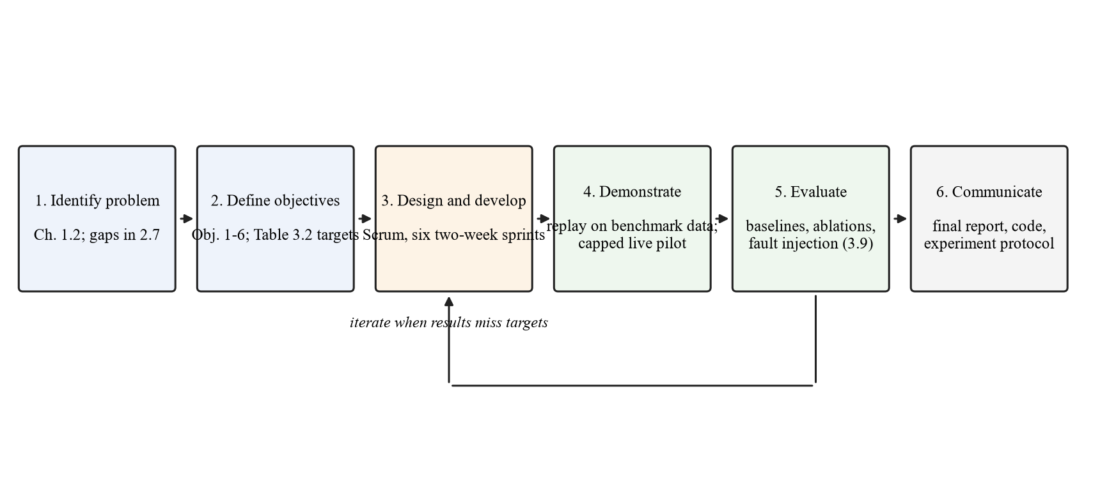
Figure 3.1: Design Science Research activities applied to the project

3.2 Requirements Elicitation
The system's users are developers and administrators who integrate LLMs into software, not members of the public. Requirements will be gathered from four sources without recruiting human participants, a decision recorded by the team and to be confirmed with the supervisor:
• Review of existing systems. The documentation of OpenRouter, LiteLLM, Portkey, vLLM Semantic Router and Not Diamond (Section 2.5) will be analysed for features, configuration options and documented limits.
• Document analysis. The OpenAI-compatible chat API will serve as the interface contract. Provider API references will be examined for request format, error codes, rate limiting behaviour, token cost and timeout.
• Literature. The gaps and evaluation practices in Chapter Two will be turned into requirements, for example that routing overhead must be measured (Lu et al., 2026) and that silent failures must be detected (Pandey & Singh, 2026b).
• Failure catalogues. From gateway issue reports and incident study (Pandey & Singh, 2026b; Yan et al., 2025), failure scenarios to be considered by reliability controller will be listed.
Wahida and Kabiru will capture the candidate requirements and put it in one sheet (with sources). The team will then cluster, write (including user stories with acceptance criteria) and prioritise (with MoSCoW) the requirements during the Sprint 1 review. If there is a request for user input from the supervisor, there will be a short questionnaire to five to eight students and junior developers which will be added together with information sheet and consent form in Appendix C.

3.3 Analysis of the Existing System

3.3.1 Description of the Existing System
In the current setup, the developer picks a model, puts its name in code or config, and sends all requests to that model through the provider SDK or OpenAI-compatible gateway. If they use a gateway, it could distribute requests among instances of this model and, on error, switch to another named model (LiteLLM, n.d.-a; Portkey, n.d.-b). If the per-prompt routing exists, the developer activates the vendor feature (and goes along with the vendor decisions without being able to see an evaluation of those decisions) (Dholakia, 2026; OpenRouter, n.d.-c). They look at costs afterwards on the billing page from the provider.

3.3.2 Limitations of the Existing System
• Every request pays the price of the chosen model, even when a cheaper model would answer as well (Ding et al., 2024; Ong et al., 2025).
• Choosing a small model to save money loses quality on hard requests, and the developer cannot tell which requests were affected.
• There is no per-request cost cap or deadline that the gateway enforces before sending the request.
• Fallback targets are fixed in configuration, so a failed request may go to a model that is more expensive than needed or too weak for the task.
• Retries without bounds can amplify an outage (Huang et al., 2022), and silent failures with a success status pass through unnoticed (Pandey & Singh, 2026b).
• Vendor per-prompt routing is closed or unevaluated, so teams cannot verify that it saves money without losing quality.
• Local models on the team's own GPUs are usually managed separately from hosted APIs.

3.4 The Proposed System

3.4.1 Description of the Proposed System
The proposed system is a routing gateway that exposes one OpenAI-compatible chat endpoint. A client sends a request and may add a cost cap and a deadline. The gateway removes models that cannot serve the request, predicts each remaining model's quality, cost and latency for this prompt, selects the cheapest model expected to meet the quality threshold within the limits, and calls it. If it fails in a way that can be retried, the provider's health is changed in reliability controller, and the remaining eligible models are selected again and retried (within bounded attempts). Each decision is logged with its predictions and reason. There are routing metadata in the response. The administrator registers models and prices, sets policy thresholds, and views a dashboard to see usage. The evaluator uses the same code to do replay and fault injection experiments.
The system consists of five different modules: The gateway API, Constraint filter, The prompt analyzer and suitability predictor, Selection policy, and Reliability controller with provider adapters. The model registry, request, decision, attempt, health event, quality score are stored in the PostgreSQL database.

3.4.2 Justification for the Proposed System
Table 3.1: Limitations of current practice and the proposed response
Limitation | Response in the proposed system
Every request pays the chosen model's price | Per-prompt selection of the cheapest model predicted to meet the quality threshold
Developer cannot see which requests lost quality | Each decision logged with predicted quality and reason; quality scored on evaluation sets
No enforced cost cap or deadline | Hard constraint filter rejects or excludes models whose estimated cost or latency exceeds the client's limits
Fixed fallback targets | Fallback re-runs selection on remaining eligible models within the remaining budget and time
Unbounded retries and silent failures | Bounded attempts, backoff with jitter, circuit breakers and response validation
Vendor routing unevaluated | Open code and a published evaluation against baselines with ablations
Local and hosted models managed separately | One adapter interface for Ollama and hosted APIs behind the same endpoint

3.5 Requirements Specification
The requirements below are preliminary and will be confirmed after elicitation in Sprint 1. Their IDs will be reused in the design traceability matrix (Section 3.6.8) and in the test cases in Chapter Four.

3.5.1 Functional Requirements
Table 3.2: Functional requirements
ID | Requirement | Actor | Priority
FR-01 | The system shall accept chat requests through an OpenAI-compatible endpoint and return responses in the same format. | Client developer | Must
FR-02 | The system shall authenticate each client with an API key and reject requests with a missing or invalid key. | Client developer | Must
FR-03 | The system shall accept an optional maximum cost and deadline per request. | Client developer | Must
FR-04 | The system shall exclude models that fail a hard constraint (capability, context length, cost cap, deadline or open circuit breaker). | System | Must
FR-05 | The system shall classify each prompt by task category and estimate its difficulty. | System | Must
FR-06 | The system shall retrieve the k most similar scored prompts and their per-model outcomes. | System | Must
FR-07 | The system shall predict quality, cost and latency for each eligible model. | System | Must
FR-08 | The system shall select the cheapest eligible model whose predicted quality meets the threshold and whose estimates meet the request's limits. | System | Must
FR-09 | The system shall reject a request with a reason code when no model is feasible. | System | Must
FR-10 | The system shall retry a retryable failure on the next selected model within limits on attempts, budget and deadline. | System | Must
FR-11 | The system shall maintain a circuit breaker per model endpoint with closed, open and half-open states. | System | Must
FR-12 | The system shall validate each response and treat malformed or empty bodies as failures. | System | Must
FR-13 | The system shall log each request, decision, attempt and outcome with timestamps, tokens and cost. | System | Must
FR-14 | The system shall return routing metadata (chosen model, reason, attempts) with each response. | Client developer | Should
FR-15 | The system shall allow an administrator to register models, prices and capabilities and set policy thresholds. | Administrator | Should
FR-16 | The system shall provide a dashboard of request volume, cost, latency, fallback rate and model health. | Administrator | Should
FR-17 | The system shall replay a stored dataset through any routing policy and export the results. | Evaluator | Must
FR-18 | The system shall inject timeouts, rate limits, server errors and malformed responses through a mock provider. | Evaluator | Must
FR-19 | The system shall support an optional quality cascade that escalates after a low-scoring answer. | System | Could
FR-20 | The system shall learn routing weights online from live traffic. | System | Won't (this project)

3.5.2 Non-Functional Requirements
The targets below are proposed and will be confirmed with the supervisor and frozen, with a recorded date, before any test results are inspected. The quality non-inferiority margin will be set from the variance observed in the Sprint 3 pilot and frozen at the same point.
Table 3.3: Non-functional requirements
ID | Category | Requirement | Measure / target
NFR-01 | Performance | Routing overhead added by the gateway (excluding model time) | p95 ≤ 100 ms on Machine 1 at 10 concurrent requests
NFR-02 | Performance | Deadline adherence for requests with a deadline | ≥ 95% of completed requests finish within their deadline
NFR-03 | Cost | Mean cost per request versus the always-frontier baseline | Lower, at quality within the non-inferiority margin (H₁)
NFR-04 | Reliability | Requests completed when one provider fails | ≥ 99% complete through fallback
NFR-05 | Reliability | Retry bound | No request makes more than 3 attempts; none exceeds its cost cap
NFR-06 | Accuracy | Calibration of predicted quality | Expected calibration error reported on the test set with a 95% confidence interval
NFR-07 | Security | Credentials and transport | API keys stored as salted hashes; provider keys in environment variables; TLS for hosted calls
NFR-08 | Privacy | Prompt storage | Raw prompts not stored in production logs; only hashes and features
NFR-09 | Maintainability | Test coverage of selection and reliability modules | ≥ 80% line coverage
NFR-10 | Compatibility | Client compatibility | Works unchanged with the official OpenAI Python client by changing the base URL

3.5.3 Use Case Model
Figure 3.2 shows the actors and use cases. The client developer sends requests, sets limits and reads routing metadata. The administrator registers models and prices, configures policy and fallback settings and views the dashboard. The evaluator runs replay and fault-injection experiments. Model providers are secondary actors that receive calls. "Send chat request" always includes model selection and, when a call fails, fallback.
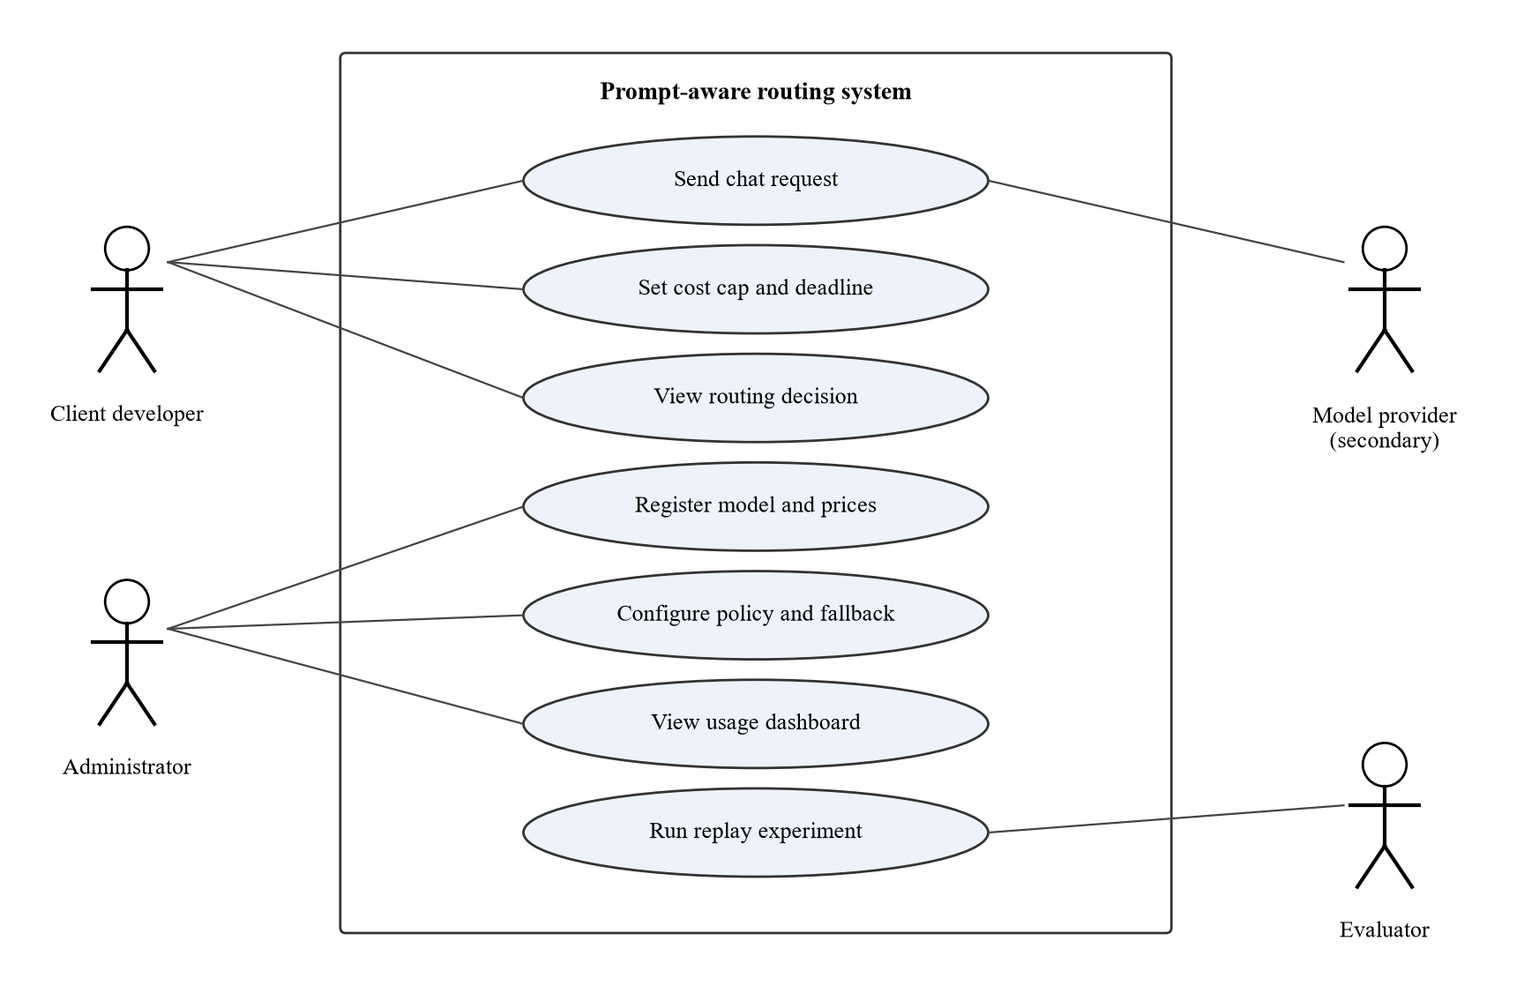
Figure 3.2: Use case diagram
Table 3.4: Use case description for "Send chat request"
Field | Description
Name | Send chat request (UC-01)
Actor | Client developer (primary); model provider (secondary)
Preconditions | Client holds a valid API key; at least one model is registered and its breaker is not open
Main flow | 1. Client sends a chat request with optional cost cap and deadline. 2. Gateway authenticates and validates it. 3. Constraint filter removes ineligible models. 4. Predictor estimates quality, cost and latency for each eligible model. 5. Policy selects the cheapest feasible model. 6. Adapter calls the model. 7. Gateway validates the response, logs the outcome and returns it with routing metadata.
Alternative flows | 3a. No eligible model: return an error with a reason code. 6a. Retryable failure: record health, re-run step 5 on remaining models while attempts, budget and time remain. 6b. Non-retryable failure or limits exhausted: return an error with the attempt history.
Postconditions | Request, decision and attempts are stored; cost is charged to the client's usage

3.6 System Design

3.6.1 System Architecture
The system uses a layered, modular architecture inside one service: an API layer (gateway), a decision layer (constraint filter, prompt analyser, suitability predictor and selection policy), an execution layer (reliability controller and adapters) and a data layer (PostgreSQL). A single service is preferred over microservices because the routing decision must add little latency (NFR-01) and the team is small; separating the layers by interface still lets each be unit-tested and replaced, for example to swap the predictor during ablation. Figure 3.3 depicts the architecture and how it is deployed on the two laptops: the router, database, and local model are running on Machine 1, while the evaluation harness, load generator, and mock provider are running on Machine 2 to avoid contention between the router and the test traffic.
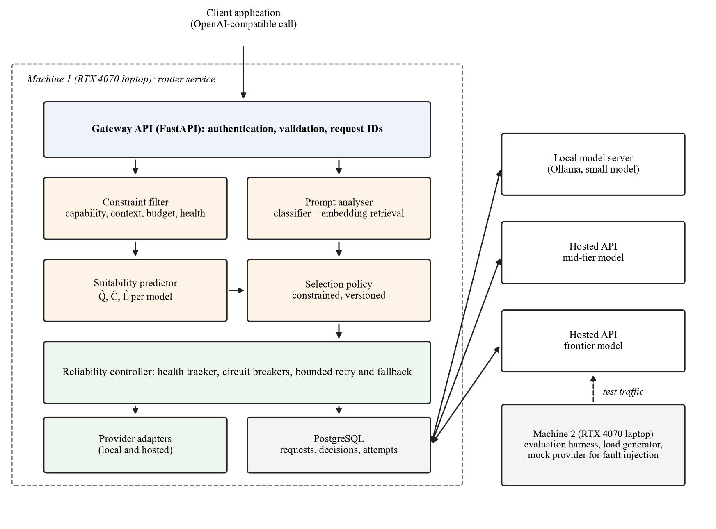
Figure 3.3: System architecture and deployment

3.6.2 Structural Design (Class Diagram)
The main classes follow the modules. Gateway receives requests and coordinates the flow. ConstraintFilter holds the hard rules and returns eligible models. PromptAnalyser computes the embedding, task category and difficulty. SuitabilityPredictor combines classifier output and retrieved neighbour outcomes into Q̂ per model, and CostEstimator and LatencyEstimator produce Ĉ and L̂. SelectionPolicy is an interface with implementations for the constrained policy, the weighted utility and each baseline, which lets the evaluator swap policies without changing other code. ReliabilityController owns one CircuitBreaker per model endpoint and a RetryPolicy. ProviderAdapter is an interface implemented by OllamaAdapter, HostedApiAdapter and MockProviderAdapter. Repository classes write to the database. The full class diagram with attributes and methods will be added in the final report.

3.6.3 Behavioural Design (Sequence and Activity Diagrams)
In the case of a normal request, the gateway will call constraint filter, then prompt analyser, predictor, policy in order, and finally the reliability controller (which in turn will call the chosen adapter and make a log of the attempt). In the case of failure, the controller will log the failure in the breaker, ask policy to try again with the remaining available models (with reduced budget and deadline), and call the next adapter. The flow is depicted in an activity diagram in Figure 3.5 of Section 3.6.5. Sequence diagrams for normal path and fallback will also be included in the final report.

3.6.4 Database Design
Figure 3.4 shows the entity relationship diagram. A provider offers many models. A client sends many requests; each request has one routing decision, which leads to one or more attempts, each against one model. Each attempt may receive one quality score during evaluation. Health events record breaker state changes per model. The schema is in third normal form: each table has a single-column key, every non-key attribute depends on the whole key, and no non-key attribute depends on another (for example, prices are stored on MODEL, not repeated on ATTEMPT; the cost on ATTEMPT is the charged amount at the time of the call, kept because prices change). The final report will provide a complete data dictionary.
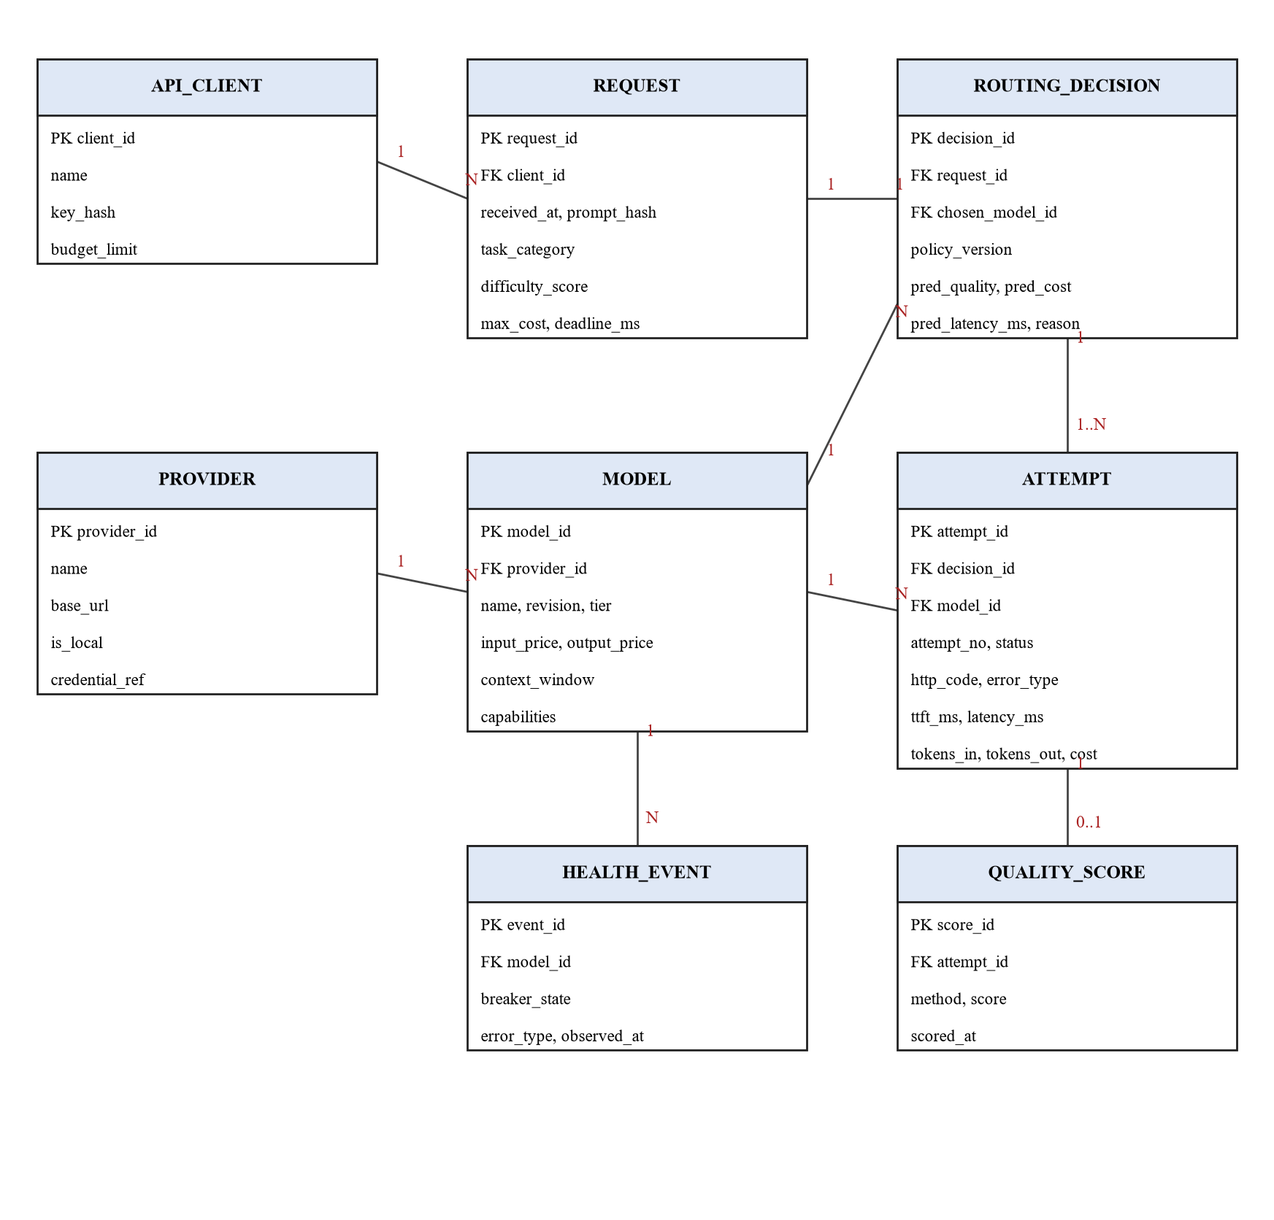
Figure 3.4: Entity relationship diagram
Table 3.5: Main relational tables (draft)
Table | Key fields | Purpose
provider | provider_id (PK), name, base_url, is_local, credential_ref | Model hosts; credential_ref names an environment variable, never the key itself
model | model_id (PK), provider_id (FK), name, revision, tier, input_price, output_price, context_window, capabilities | Registry of candidate models
api_client | client_id (PK), name, key_hash, budget_limit | Clients of the gateway
request | request_id (PK), client_id (FK), received_at, prompt_hash, task_category, difficulty_score, max_cost, deadline_ms | One row per incoming request
routing_decision | decision_id (PK), request_id (FK), chosen_model_id (FK), policy_version, pred_quality, pred_cost, pred_latency_ms, reason | The decision and its predictions
attempt | attempt_id (PK), decision_id (FK), model_id (FK), attempt_no, status, http_code, error_type, ttft_ms, latency_ms, tokens_in, tokens_out, cost | Each call made, including fallbacks
health_event | event_id (PK), model_id (FK), breaker_state, error_type, observed_at | Breaker state changes
quality_score | score_id (PK), attempt_id (FK), method, score, scored_at | Evaluation scores for answers

3.6.5 Algorithm and Model Design
Features and predictor. Each prompt q is embedded with a sentence-embedding model (Reimers & Gurevych, 2019). A logistic-regression classifier on the embedding predicts the task category, and a second set of per-model logistic-regression heads predicts the probability that each model m answers acceptably (Pedregosa et al., 2011). In parallel, the k nearest prompts in the training history are retrieved by cosine similarity, and their recorded scores for model m are averaged with similarity weights to give a retrieval estimate. The hybrid estimate is
Q̂(m, q) = w · p_clf(m, q) + (1 − w) · r_kNN(m, q),
where p_clf is the classifier probability, r_kNN the retrieval estimate and w a weight tuned on the validation split. The estimator form, k and w will be chosen on validation data only. Estimated cost is Ĉ(m, q) = n_in · price_in(m) + n̂_out(m, q) · price_out(m), where n_in is the counted input tokens and n̂_out the median output length of the retrieved neighbours for model m. Estimated latency L̂(m, q) is the 95th percentile of recent completion times for model m at similar output lengths, taken from the attempt log.
Selection. Let E be the models that pass the hard constraints, τ the minimum predicted quality, c the request's cost cap and d its deadline. The policy selects
m* = argmin Ĉ(m, q) over m ∈ E such that Q̂(m, q) ≥ τ, Ĉ(m, q) ≤ c and L̂(m, q) ≤ d,
breaking ties by higher Q̂. If no model meets τ, the policy chooses the eligible model with the highest Q̂ that still meets c and d, and marks the decision as below threshold. If no model meets c and d, the request is rejected with a reason code. The threshold τ will be swept on the validation split to trace the quality–cost curve, and the operating value fixed before testing.
Fallback. On a timeout, rate limit, server error or invalid response, the controller marks a failure on that model's breaker. After N consecutive failures the breaker opens, then will reject requests during cool-down. When half-open, only one trial request is allowed. The controller removes the failed model, deducts consumed cost from the cap and elapsed time from the deadline, then re-selects. At most three attempts are made per request (NFR-05), with exponential backoff and jitter between attempts to the same provider. Failure thresholds, cool-down times and backoff values will be chosen from the fault-injection experiments in Sprint 5. Figure 3.5 shows the complete algorithm.
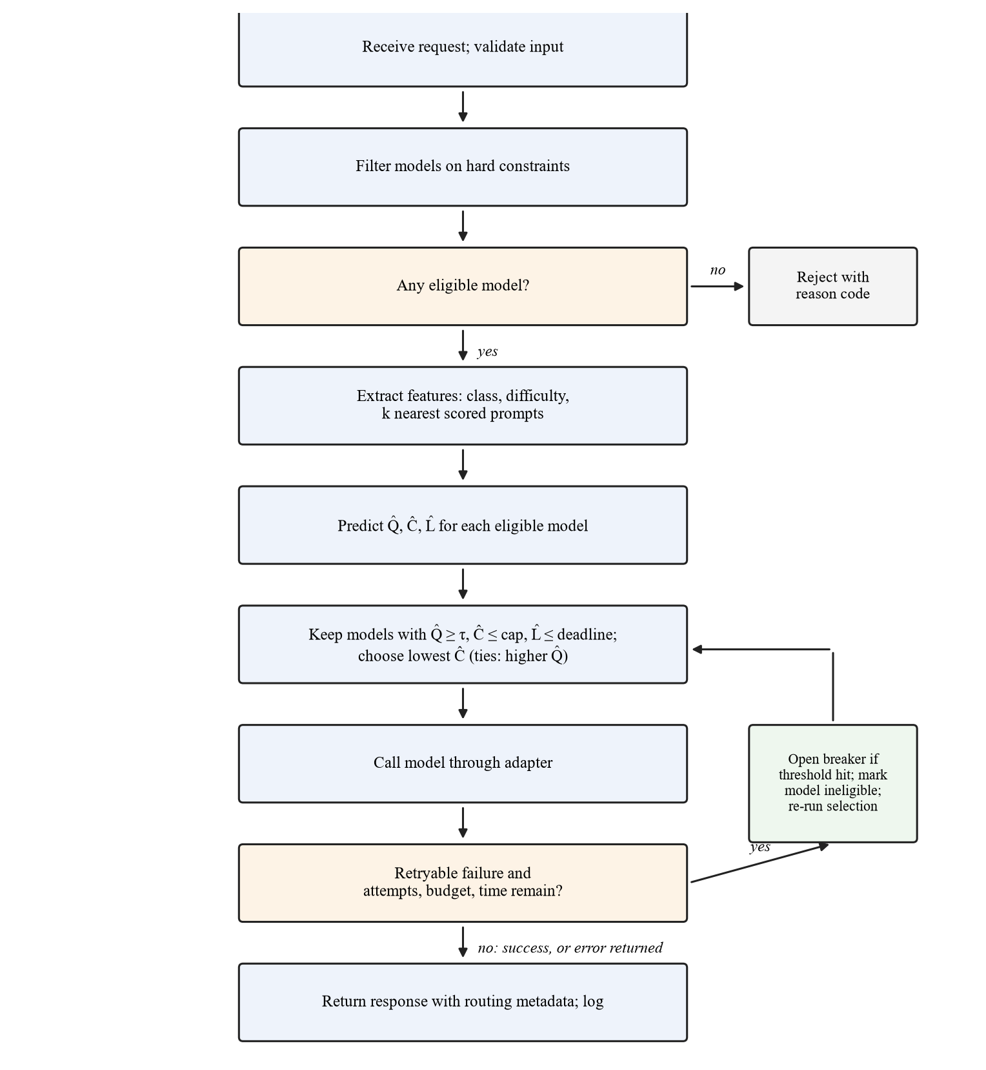
Figure 3.5: Routing and fallback algorithm

3.6.6 User Interface Design
The API is the primary interface of the system. The admin dashboard is a secondary interface used to read the system, with four views: overview (number of requests, spend, p95 latency and fallback rate), request log (model that was used, rationale behind every decision), model view (prices, capabilities and breaker state) and experiments view (list of replay runs and quality-cost curves). Figure 3.6 shows the overview wireframe with sample data. The design will use plain-language reasons ("cheapest feasible", "fallback after timeout"), consistent layouts across pages, text labels alongside colour for breaker states, and keyboard-accessible controls.
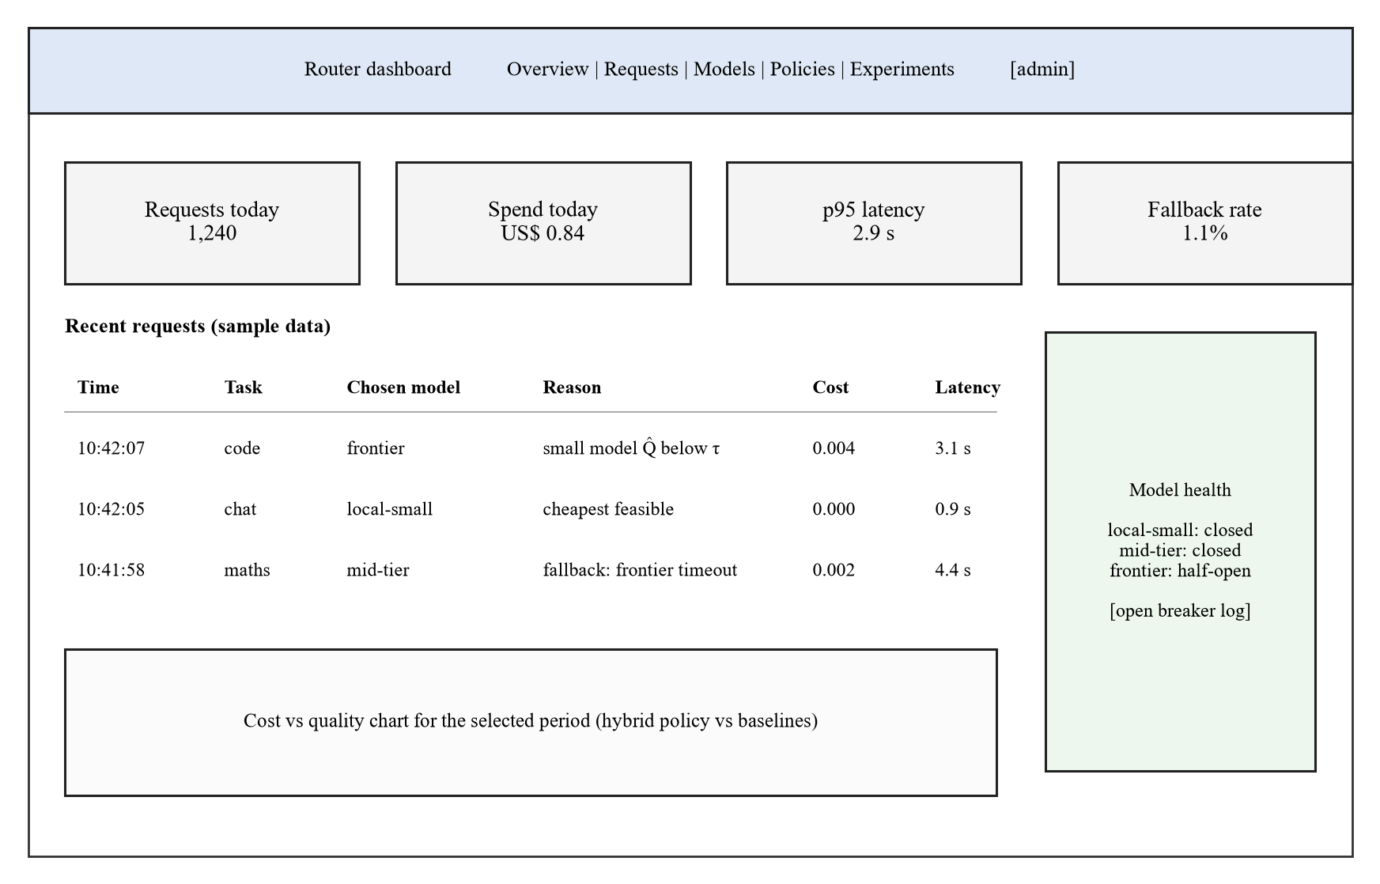
Figure 3.6: Wireframe of the administrator dashboard overview (sample data)

3.6.7 Security and Privacy Design
Clients authenticate with API keys stored as salted hashes. Provider credentials are read from environment variables and never written to the database or logs. Hosted calls use TLS. Inputs are validated against the OpenAI request schema and size limits before processing, and dashboard pages require an administrator login. Production logs will store a hash and derived features of each prompt rather than the raw text, and evaluation data will come from public benchmarks, so no personal data is expected to be processed. If any personal data is to be processed subsequently, the architecture will conform to the Nigeria Data Protection Act 2023 (such as purpose limitation, data minimisation). (Federal Republic of Nigeria, 2023)

3.6.8 Requirements Traceability
Table 3.6: Draft traceability from requirements to design and tests
Requirement | Design element | Planned test
FR-01, NFR-10 | Gateway API (Figure 3.3) | Call the endpoint with the OpenAI Python client
FR-04, FR-09 | Constraint filter; reject branch (Figure 3.5) | Requests exceeding context, cost cap or deadline
FR-05 to FR-07 | Prompt analyser and suitability predictor | Predictor accuracy and calibration on the test split
FR-08 | Constrained selection policy | Replay comparison against baselines
FR-10 to FR-12, NFR-04, NFR-05 | Reliability controller, circuit breaker, response validation | Fault-injection scenarios with the mock provider
FR-13, FR-14 | Repository classes; attempt and decision tables (Figure 3.4) | Log completeness check after replay
NFR-01, NFR-02 | Gateway and latency estimator | Load test at 10 concurrent requests from Machine 2

Test IDs will be assigned when the test plan is written in Sprint 2.

3.7 Data Collection and Preparation
Sources. The primary source will be LLMRouterBench, which provides stored responses and scores for 33 models across 21 datasets (Li et al., 2026); RouterBench, with 11 models and about 405,000 samples, is the fallback (Hu et al., 2024). The team will first check that the chosen candidate models have aligned, scored outputs on the same prompts. Unrelated scores will not be joined by benchmark name. Code and data licence terms will be checked for each source, and raw benchmark data will not be redistributed.
Labels. For each prompt and model the label is the benchmark's score, converted to a binary "acceptable" label for the classifier heads using the benchmark's own correctness rule, and kept as a continuous score for retrieval. The scoring method of each label (exact match, unit test or LLM judge) will be recorded, given the biases of judge scores (Zheng et al., 2023).
Local model check. The quantised local model may differ from the full precision model evaluated in the benchmark, and a stratified sample of ~300 prompts will be evaluated on the local model using the benchmark evaluation procedure. If there is poor correlation with the stored labels then the labels for the local model will be set based only on the output of the local model for this sample of prompts, and this will be noted as a limitation.
Splits. Prompts will be split 60/20/20 into training, validation and test sets, stratified by dataset and grouped so that near-duplicate prompts (cosine similarity above 0.95) fall in the same split. The retrieval index will contain training prompts only. All tuning (k, w, τ and baseline settings) will use the validation set; the test set will be used once, after targets are frozen. A second test on datasets held out entirely from training will measure generalisation.
Live pilot data. A capped live pilot of a few hundred prompts drawn from the test split will measure real latency, token usage and cost on the local and hosted models. Prompts are public benchmark items, so no personal data is involved.

3.8 Tools and Technologies
Table 3.7: Tools and technologies
Tool / technology | Purpose | Justification
Python 3.12 | Main language | One language for the gateway, predictor and analysis; strong ML libraries
FastAPI | Gateway API | Asynchronous request handling; automatic request validation; OpenAPI documentation
sentence-transformers | Prompt embeddings | Small embedding models run on CPU or GPU in milliseconds (Reimers & Gurevych, 2019)
scikit-learn | Classifier and calibration | Logistic regression and calibration tools; fast to retrain (Pedregosa et al., 2011)
FAISS or NumPy | Nearest-neighbour search | Exact or approximate cosine search over the training index
Ollama | Local model serving | Runs quantised models on the RTX 4070 laptops under Windows with an HTTP API
Hosted model APIs | Mid-tier and frontier models | Required for the mixed pool; called through a common adapter
PostgreSQL | Relational data | Normalised schema for requests, decisions and attempts (Section 3.6.4)
Streamlit | Administrator dashboard | Component-based UI; Easy Integration
pytest, Locust or k6 | Unit, integration and load tests | Coverage for NFR-09; concurrent load for NFR-01
Git and GitHub | Version control and reviews | Pull-request reviews; issue tracking per sprint
draw.io, Python (matplotlib) | Diagrams and charts | Figures and quality–cost plots

3.9 Evaluation Plan
Testing will be done at four levels: unit tests for the filter, predictor, policy, breaker and retry logic; integration tests for the path from gateway to adapter to database; system tests on replay and live pilot traffic; and acceptance tests derived from the user stories. Table 3.8 sets out the evaluation of each objective.
Table 3.8: Evaluation plan by objective
Objective | Method | Metric | Target / test
1. Requirements | Review of the requirements against sources and user stories | Requirements with source, ID and priority; supervisor sign-off | All Must requirements traced to a source
2. Design | Design review; traceability matrix | Requirements traced to design elements | 100% of Must requirements traced
3. Predictor (RQ3) | Held-out test split; held-out datasets | AUROC and accuracy of acceptable-answer prediction; expected calibration error | Report with 95% bootstrap confidence intervals; compare with k-NN alone and classifier alone
4. Selection (RQ4) | Paired replay of the test split through each policy | Mean quality, mean cost, p95 latency, constraint violations | Quality within the non-inferiority margin; lower cost than always-frontier (Wilcoxon signed-rank, one-sided, α = 0.05); acceptable/unacceptable outcomes compared with McNemar's test
5. Reliability (RQ5) | Fault injection with the mock provider: timeouts, 429s, 5xx, malformed bodies, slow responses | Completion rate, added latency, added cost, attempts per request | ≥ 99% completion with one provider failing (NFR-04); ≤ 3 attempts (NFR-05)
6. Ablation (RQ6) | Replay with components removed | Change in cost at fixed quality; area under quality–cost curve | Report each component's effect with confidence intervals
Overhead | Load test from Machine 2 at 10 concurrent requests | Gateway overhead p95; deadline adherence | p95 ≤ 100 ms (NFR-01); ≥ 95% within deadline (NFR-02)

Baselines. All comparisons will contain: always the frontier model, always the least expensive eligible model, rule-based routing by task type, only k-NN retrieval, only classifier, weighted utility policy, and oracle (least expensive model giving an acceptable answer, calculated using stored labels), as an upper bound. Note: a simpler baseline equivalent to the hybrid is a valid outcome, and will be presented that way.
Statistics. As the same prompts will be used for all policies, paired comparisons are made. For binary cases (acceptable or not), McNemar's test will be used. For per-request cost and latency, the Wilcoxon signed-rank test is used (Wohlin et al., 2012). Non-inferiority will be evaluated based on whether the lower bound of 95% confidence interval for the difference in quality is larger than the negative margin. Live pilot results are reported separately from offline replay. This is because they use fewer prompts and actual network conditions.

3.10 Ethical Considerations
The project is not recruiting human participants, therefore there is no need for a consent procedure for the core evaluation. The stance that ethical approval is not required has been documented but the team will get this confirmed in writing from the supervisor before Sprint 1, and will apply for ethical approval from the university research ethics committee prior to collecting data if this is required. If a requirements questionnaire is added, participation will be voluntary, anonymous and preceded by an information sheet and signed consent form (Appendix C), and no names, emails or raw prompts will be stored.
Evaluation data will be public benchmark prompts used under their licence terms. Prompts sent to hosted APIs will contain no personal data. Provider and client credentials will be protected as described in Section 3.6.7, and the Nigeria Data Protection Act 2023 will be followed for any personal data that is processed (Federal Republic of Nigeria, 2023). Use of generative AI tools in preparing this proposal is declared in the front matter, and all AI-assisted text, summaries and figures will be checked by the team against the original sources before submission.

3.11 Risk Assessment
Table 3.9: Risk assessment (L = likelihood, I = impact)
Risk | L | I | Mitigation
No benchmark has aligned scored outputs for the chosen models | M | H | Check coverage in Sprint 1; choose a smaller aligned pool from the same benchmark; report the change
Hosted API spending exceeds the cap | M | M | Use stored outputs for training and replay; hard spending limit on each provider key; small live pilot
Local model too slow or too large for laptop VRAM | M | M | Test quantised models in Sprint 1; use a smaller model; keep vLLM as an option
Hybrid predictor does not beat simple baselines | M | M | Treat as a valid finding; report the ablation honestly
Benchmark licence forbids the intended use | L | H | Check terms before download; switch to RouterBench or another licensed source
Provider model or price changes during the study | H | L | Record revisions and price tables per experiment; fix them for the test period
Scope creep (memory, online learning, extra models) | M | M | Freeze Must requirements after Sprint 2; log extras as future work
Team member unavailable during a sprint | M | M | Pair members on each module; shared repository and documentation

3.12 Work Plan
Work is planned in 6x2-weeks sprints throughout both semesters (with report writing interleaved with implementation). The team roles are as specified in the statement of contributions. Owners stick to the team roles.
Table 3.10: Sprint plan
Sprint | Weeks | Owners | Deliverable
1. Requirements, data access and environment | Sem. 1, Weeks 9–10 | Wahida, Kabiru, Solomon | Requirements list with MoSCoW; benchmark coverage and licence check; environment on both laptops
2. Gateway, adapters and database | Sem. 1, Weeks 11–12 | Waris, Maryam | OpenAI-compatible endpoint; Ollama and hosted adapters; schema and logging; frozen Must requirements
3. Baselines and replay harness | Sem. 1, Weeks 13–14 | Maryam, Wahida, Solomon | Baseline policies; replay tool; pilot run to set the non-inferiority margin
4. Hybrid predictor and constrained policy | Sem. 2, Weeks 1–2 | Solomon, Waris | Classifier, retrieval and hybrid estimates; constrained policy; validation tuning; targets frozen
5. Reliability controller and fault injection | Sem. 2, Weeks 3–4 | Waris, Maryam | Breakers, bounded retries, response validation; mock provider; fault-injection results
6. Evaluation, dashboard and hardening | Sem. 2, Weeks 5–6 | All; Kabiru (dashboard) | Test-set evaluation, ablations, live pilot; dashboard; release candidate

The timing of the calendar weeks will be adjusted to match the university timetable once it is available. Chapters Four and Five will be written in Sprints 5 & 6.

3.13 Budget
The team already owns the two laptops, and all software is free or open source, so the main costs are hosted API usage and incidental expenses. Amounts will be filled in from at least two written quotes or current provider price lists before submission.
Table 3.11: Budget
Item | Quantity | Cost (₦) | Source
Two RTX 4070 laptops (development and local model) | 2 | 0 (owned) | Team members
Software (Python, FastAPI, PostgreSQL, Ollama, GitHub) | n/a | 0 (free or open source) | Open source
Hosted API credit for live pilot and local-model checks | Capped pilot | [₦ amount from current price lists] | Team contribution
Internet data for downloads and API calls | 6 sprints | [₦ amount] | Team contribution
Printing and binding of proposal and final report | 2 submissions | [₦ amount from quotes] | Team contribution
Contingency (10%) | n/a | [₦ amount] | Team contribution
Total |  | [₦ total]

3.14 Expected Outcomes
The project is expected to deliver a working routing gateway with source code; a requirements and design specification; a replay and fault-injection harness with an experiment protocol; an evaluation report comparing the hybrid router with baselines, including ablations and live pilot timing; and the final report. If the results are clear, the team will consider preparing a short paper.

3.15 Chapter Summary
The project will follow Design Science Research with Scrum development in six sprints. Requirements will come from existing gateways, provider documentation, the literature and failure catalogues, without human participants unless the supervisor asks for them. The design is a layered routing service with a constraint filter, a hybrid suitability predictor that combines a lightweight classifier with embedding retrieval, a constrained selection policy and a reliability controller with circuit breakers and bounded fallback. It will be evaluated offline on licensed benchmark outputs with leakage-free splits, live on a capped pilot, and under injected failures, against simple baselines with paired statistical tests and ablations, with targets fixed before testing.

REFERENCES
Aderaldo, C. M., & Mendonça, N. C. (2026). ResilienceBench-Operator: A Kubernetes extension for systematic evaluation of microservice resilience patterns. Journal of Software Engineering Research and Development, 14, 179–208. https://doi.org/10.5753/jserd.2026.6965
Aggarwal, P., Madaan, A., Anand, A., Potharaju, S. P., Mishra, S., Zhou, P., Gupta, A., Rajagopal, D., Kappaganthu, K., Yang, Y., Upadhyay, S., Faruqui, M., & Mausam. (2024). AutoMix: Automatically mixing language models. In Advances in Neural Information Processing Systems (Vol. 37). Curran Associates. https://doi.org/10.52202/079017-4164
Agrawal, A., Agarwal, A., Kedia, N., Mohan, J., Kundu, S., Kwatra, N., Ramjee, R., & Tumanov, A. (2024a). Etalon: Holistic performance evaluation framework for LLM inference systems [Preprint]. arXiv. https://doi.org/10.48550/arXiv.2407.07000
Chen, L., Zaharia, M., & Zou, J. (2024a). FrugalGPT: How to use large language models while reducing cost and improving performance. Transactions on Machine Learning Research. https://openreview.net/forum?id=cSimKw5p6R
Chen, S., Jia, Z., Khan, S., Krishnamurthy, A., & Gibbons, P. B. (2025). SLOs-Serve: Optimized serving of multi-SLO LLMs [Preprint]. arXiv. https://doi.org/10.48550/arXiv.2504.08784
Chen, S., Jiang, W., Lin, B., Kwok, J. T., & Zhang, Y. (2024b). RouterDC: Query-based router by dual contrastive learning for assembling large language models. In Advances in Neural Information Processing Systems (Vol. 37). Curran Associates. https://doi.org/10.52202/079017-2120
Da, W., & Kalyvianaki, E. (2026). RouteBalance: Fused model routing and load balancing for heterogeneous LLM serving [Preprint]. arXiv. https://doi.org/10.48550/arXiv.2606.17949
Dekoninck, J., Baader, M., & Vechev, M. (2025). A unified approach to routing and cascading for LLMs. In Proceedings of the 42nd International Conference on Machine Learning (Vol. 267, pp. 12987–13010). PMLR. https://proceedings.mlr.press/v267/dekoninck25a.html
Dholakia, K. (2026, July 13). Auto Router v2: One router for complexity, semantic, and adaptive routing. LiteLLM. Retrieved October 31, 2026, from https://docs.litellm.ai/blog/autorouter-v2
Ding, D., Mallick, A., Wang, C., Sim, R., Mukherjee, S., Rühle, V., Lakshmanan, L. V. S., & Awadallah, A. H. (2024). Hybrid LLM: Cost-efficient and quality-aware query routing. In Proceedings of the Twelfth International Conference on Learning Representations. https://openreview.net/forum?id=02f3mUtqnM
Ding, D., Mallick, A., Zhang, S., Wang, C., Madrigal, D., Garcia, M. D. C. H., Xia, M., Lakshmanan, L. V. S., Wu, Q., & Rühle, V. (2025). BEST-Route: Adaptive LLM routing with test-time optimal compute. In Proceedings of the 42nd International Conference on Machine Learning (Vol. 267, pp. 13870–13884). PMLR. https://proceedings.mlr.press/v267/ding25d.html
Federal Republic of Nigeria. (2023). Nigeria Data Protection Act, 2023. Nigeria Data Protection Commission. https://ndpc.gov.ng
Griggs, T., Liu, X., Yu, J., Kim, D., Chiang, W.-L., Cheung, A., & Stoica, I. (2024). Mélange: Cost efficient large language model serving by exploiting GPU heterogeneity [Preprint]. arXiv. https://doi.org/10.48550/arXiv.2404.14527
Gujarati, A., Karimi, R., Alzayat, S., Hao, W., Kaufmann, A., Vigfusson, Y., & Mace, J. (2020). Serving DNNs like Clockwork: Performance predictability from the bottom up. In Proceedings of the 14th USENIX Symposium on Operating Systems Design and Implementation (pp. 443–462). USENIX Association. https://www.usenix.org/conference/osdi20/presentation/gujarati
Hevner, A. R., March, S. T., Park, J., & Ram, S. (2004). Design science in information systems research. MIS Quarterly, 28(1), 75–105. https://doi.org/10.2307/25148625
Hu, Q. J., Bieker, J., Li, X., Jiang, N., Keigwin, B., Ranganath, G., Keutzer, K., & Upadhyay, S. K. (2024). RouterBench: A benchmark for multi-LLM routing system [Poster presentation]. Agentic Markets Workshop, International Conference on Machine Learning. https://doi.org/10.48550/arXiv.2403.12031
Huang, L., Magnusson, M., Muralikrishna, A. B., Estyak, S., Isaacs, R., Aghayev, A., Zhu, T., & Charapko, A. (2022). Metastable failures in the wild. In Proceedings of the 16th USENIX Symposium on Operating Systems Design and Implementation (pp. 73–90). USENIX Association. https://www.usenix.org/conference/osdi22/presentation/huang-lexiang
Huang, Z., Ling, G., Lin, Y., Chen, Y., Zhong, S., Wu, H., & Lin, L. (2025). RouterEval: A comprehensive benchmark for routing LLMs to explore model-level scaling up in LLMs. In Findings of the Association for Computational Linguistics: EMNLP 2025 (pp. 3860–3887). Association for Computational Linguistics. https://doi.org/10.18653/v1/2025.findings-emnlp.208
Kitchenham, B., & Charters, S. (2007). Guidelines for performing systematic literature reviews in software engineering (EBSE Technical Report EBSE-2007-01). Keele University and Durham University.
Kwon, W., Li, Z., Zhuang, S., Sheng, Y., Zheng, L., Yu, C. H., Gonzalez, J., Zhang, H., & Stoica, I. (2023). Efficient memory management for large language model serving with PagedAttention. In Proceedings of the 29th Symposium on Operating Systems Principles (pp. 611–626). ACM. https://doi.org/10.1145/3600006.3613165
Li, H., Zhang, Y., Guo, Z., Wang, C., Tang, S., Zhang, Q., Chen, Y., Qi, B., Ye, P., Bai, L., Wang, Z., & Hu, S. (2026). LLMRouterBench: A massive benchmark and unified framework for LLM routing. In Findings of the Association for Computational Linguistics: ACL 2026 (pp. 37733–37754). Association for Computational Linguistics. https://doi.org/10.18653/v1/2026.findings-acl.1881
LiteLLM. (n.d.-a). Router: Load balancing. Retrieved October 31, 2026, from https://docs.litellm.ai/docs/routing
LiteLLM. (n.d.-b). [Beta] Auto routing. Retrieved October 31, 2026, from https://docs.litellm.ai/docs/proxy/auto_routing
LiteLLM. (n.d.-d). vLLM. Retrieved October 31, 2026, from https://docs.litellm.ai/docs/providers/vllm
Liu, X., Chen, H., Lu, S., Ovadia, Y., Wen, G., Wu, H., Tan, Z., Zhang, J., Zedan, S., Kerido, Y., Weiss, L., Zhang, H., Yu, B., Balum, A., Limoy, N., Samara, A., Fan, B., Salisbury, B., Cook, R., . . . He, B. (2026). vLLM Semantic Router: Signal driven decision routing for mixture-of-modality models [Preprint]. arXiv. https://doi.org/10.48550/arXiv.2603.04444
Lu, Y., Liu, R., Yuan, J., Cui, X., Zhang, S., Liu, H., & Xing, J. (2026). RouterArena: An open platform for comprehensive comparison of LLM routers. In The Fourteenth International Conference on Learning Representations. https://doi.org/10.48550/arXiv.2510.00202
Mohammadshahi, A., Shaikh, A. R., & Yazdani, M. (2024). Routoo: Learning to route to large language models effectively [Preprint]. arXiv. https://doi.org/10.48550/arXiv.2401.13979
Moslem, Y., & Kelleher, J. D. (2026). Dynamic model routing and cascading for efficient LLM inference: A survey. Transactions on Machine Learning Research. https://openreview.net/forum?id=ypRg1TvQaM
Not Diamond. (n.d.-a). What is model routing? Retrieved October 31, 2026, from https://docs.notdiamond.ai/docs/what-is-model-routing
Not Diamond. (n.d.-c). Training a custom router. Retrieved October 31, 2026, from https://docs.notdiamond.ai/docs/router-training-quickstart
Not Diamond. (n.d.-e). Pricing. Retrieved October 31, 2026, from https://www.notdiamond.ai/pricing
Nygard, M. T. (2018). Release it! Design and deploy production-ready software (2nd ed.). Pragmatic Bookshelf.
Ong, I., Almahairi, A., Wu, V., Chiang, W.-L., Wu, T., Gonzalez, J. E., Kadous, M. W., & Stoica, I. (2025). RouteLLM: Learning to route LLMs with preference data. In Proceedings of the Thirteenth International Conference on Learning Representations. https://openreview.net/forum?id=8sSqNntaMr
OpenRouter. (n.d.-a). Provider routing. Retrieved October 31, 2026, from https://openrouter.ai/docs/guides/routing/provider-selection
OpenRouter. (n.d.-c). Auto Router. Retrieved October 31, 2026, from https://openrouter.ai/docs/guides/routing/routers/auto-router
Pandey, V., & Singh, G. (2026a). ContinuityBench: A benchmark and systems study of stateful failover in multi-provider LLM routing [Preprint]. arXiv. https://doi.org/10.48550/arXiv.2607.15899
Pandey, V., & Singh, G. (2026b). FailureAtlas: A taxonomy of failure modes in multi-provider LLM serving infrastructure [Preprint]. arXiv. https://doi.org/10.48550/arXiv.2607.17525
Pedregosa, F., Varoquaux, G., Gramfort, A., Michel, V., Thirion, B., Grisel, O., Blondel, M., Prettenhofer, P., Weiss, R., Dubourg, V., Vanderplas, J., Passos, A., Cournapeau, D., Brucher, M., Perrot, M., & Duchesnay, É. (2011). Scikit-learn: Machine learning in Python. Journal of Machine Learning Research, 12, 2825–2830.
Peffers, K., Tuunanen, T., Rothenberger, M. A., & Chatterjee, S. (2007). A design science research methodology for information systems research. Journal of Management Information Systems, 24(3), 45–77. https://doi.org/10.2753/MIS0742-1222240302
Portkey. (n.d.-a). Load balancing. Retrieved October 31, 2026, from https://portkey.ai/docs/product/ai-gateway/load-balancing
Portkey. (n.d.-b). Fallbacks. Retrieved October 31, 2026, from https://portkey.ai/docs/product/ai-gateway/fallbacks
Portkey. (n.d.-c). Conditional routing. Retrieved October 31, 2026, from https://portkey.ai/docs/product/ai-gateway/conditional-routing
Portkey. (n.d.-d). Circuit breaker. Retrieved October 31, 2026, from https://portkey.ai/docs/product/ai-gateway/circuit-breaker
Reimers, N., & Gurevych, I. (2019). Sentence-BERT: Sentence embeddings using Siamese BERT-networks. In Proceedings of the 2019 Conference on Empirical Methods in Natural Language Processing and the 9th International Joint Conference on Natural Language Processing (pp. 3982–3992). Association for Computational Linguistics. https://doi.org/10.18653/v1/D19-1410
Romero, F., Li, Q., Yadwadkar, N. J., & Kozyrakis, C. (2021). INFaaS: Automated model-less inference serving. In Proceedings of the 2021 USENIX Annual Technical Conference (pp. 397–411). USENIX Association. https://www.usenix.org/conference/atc21/presentation/romero
Šakota, M., Peyrard, M., & West, R. (2024). Fly-swat or cannon? Cost-effective language model choice via meta-modeling. In Proceedings of the 17th ACM International Conference on Web Search and Data Mining (pp. 606–615). Association for Computing Machinery. https://doi.org/10.1145/3616855.3635825
Schwaber, K., & Sutherland, J. (2020). The Scrum guide. https://scrumguides.org/scrum-guide.html
Shirkavand, R., Gao, S., Yu, P., & Huang, H. (2025). Cost-aware contrastive routing for LLMs. In Advances in Neural Information Processing Systems (Vol. 38). https://proceedings.neurips.cc/paper_files/paper/2025/hash/e46eb6403af68506331f941282d838aa-Abstract-Conference.html
Shnitzer, T., Ou, A., Silva, M., Soule, K., Sun, Y., Solomon, J., Thompson, N., & Yurochkin, M. (2023). Large language model routing with benchmark datasets [Preprint]. arXiv. https://doi.org/10.48550/arXiv.2309.15789
Tang, Y.-C., Hung, J.-C., Peng, W.-C., & Yen, A.-Z. (2026). VDAR-Router: Adaptive LLMs routing via verbalized query difficulty analysis retrieval [Preprint]. arXiv. https://doi.org/10.48550/arXiv.2607.18098
Varangot-Reille, C., Bouvard, C., & Gourru, A. (2026a). Generalising LLM routing using past performance retrieval: A few-shot router is sufficient. In Proceedings of the 19th Conference of the European Chapter of the Association for Computational Linguistics (Volume 4: Student Research Workshop) (pp. 304–319). Association for Computational Linguistics. https://doi.org/10.18653/v1/2026.eacl-srw.22
Varangot-Reille, C., Bouvard, C., Ciancone, M., Gourru, A., Schaeffer, M., & Jacquenet, F. (2026b). Doing more with less: A survey on routing strategies for resource optimisation in large language model-based systems. Journal of Artificial Intelligence Research, 86. https://doi.org/10.1613/jair.1.19801
vLLM Semantic Router Team. (n.d.). vLLM Semantic Router: An open, programmable decision layer for models and compute [Computer software]. GitHub. Retrieved October 31, 2026, from https://github.com/vllm-project/semantic-router
Wohlin, C., Runeson, P., Höst, M., Ohlsson, M. C., Regnell, B., & Wesslén, A. (2012). Experimentation in software engineering. Springer. https://doi.org/10.1007/978-3-642-29044-2
Wu, F., & Silwal, S. (2025). Efficient training-free online routing for high-volume multi-LLM serving. In Proceedings of the 39th Conference on Neural Information Processing Systems. https://doi.org/10.48550/arXiv.2509.02718
Xiong, M., Hu, Z., Lu, X., Li, Y., Fu, J., He, J., & Hooi, B. (2024). Can LLMs express their uncertainty? An empirical evaluation of confidence elicitation in LLMs. In The Twelfth International Conference on Learning Representations. https://openreview.net/forum?id=gjeQKFxFpZ
Yan, H., Chen, Y., Ma, M., Wen, M., Lu, S., Zhang, S., Xu, T., Wang, R., Bansal, C., Rajmohan, S., Lin, Q., Zhang, C., & Zhang, D. (2025). An empirical study of production incidents in generative AI cloud services [Preprint]. arXiv. https://doi.org/10.48550/arXiv.2504.08865
Zhang, Y., Li, H., Chen, J., Zhang, H., Ye, P., Bai, L., & Hu, S. (2025). Beyond GPT-5: Making LLMs cheaper and better via performance-efficiency optimized routing. In Proceedings of the 2025 Seventh International Conference on Distributed Artificial Intelligence (pp. 122–129). Association for Computing Machinery. https://doi.org/10.1145/3772429.3772445
Zheng, L., Chiang, W.-L., Sheng, Y., Zhuang, S., Wu, Z., Zhuang, Y., Lin, Z., Li, Z., Li, D., Xing, E. P., Zhang, H., Gonzalez, J. E., & Stoica, I. (2023). Judging LLM-as-a-judge with MT-Bench and Chatbot Arena. In Advances in Neural Information Processing Systems (Vol. 36). https://proceedings.neurips.cc/paper_files/paper/2023/hash/91f18a1287b398d378ef22505bf41832-Abstract-Datasets_and_Benchmarks.html
Zhong, Y., Liu, S., Chen, J., Hu, J., Zhu, Y., Liu, X., Jin, X., & Zhang, H. (2024). DistServe: Disaggregating prefill and decoding for goodput-optimized large language model serving. In Proceedings of the 18th USENIX Symposium on Operating Systems Design and Implementation (pp. 193–210). USENIX Association. https://www.usenix.org/conference/osdi24/presentation/zhong-yinmin
Zhu, Y., Liu, D., Lin, Z., Tong, W., Zhong, S., & Shao, J. (2025). The LLM already knows: Estimating LLM-perceived question difficulty via hidden representations. In Proceedings of the 2025 Conference on Empirical Methods in Natural Language Processing (pp. 1160–1176). Association for Computational Linguistics. https://doi.org/10.18653/v1/2025.emnlp-main.61
Zhuang, R., Wu, T., Wen, Z., Li, A., Jiao, J., & Ramchandran, K. (2025). EmbedLLM: Learning compact representations of large language models. In The Thirteenth International Conference on Learning Representations. https://doi.org/10.48550/arXiv.2410.02223

APPENDICES
Appendix A: Source code repository link (to be added when the repository is created in Sprint 2)
Appendix B: Dataset and licence register for the benchmark sources
Appendix C: Requirements questionnaire, information sheet and consent form (only if the supervisor requires user input)
Appendix D: Test cases and traceability matrix (final report)
Appendix E: Generative AI use log
Appendix F: Project schedule (Gantt chart) and record of group meetings with the supervisor

